**Conducting Quality Control Measure**

1. **Implemented Measures**

After defining the quality that our product must have for the first sprint, we performed those tasks and observe their progress via Trello, some of the evidence is also collected to determine our quality performance and progress.

We separated the testing into different groups that have similar component for ease of backtracking and review and during this period, we have tested 3 groups of tests that has been done.

*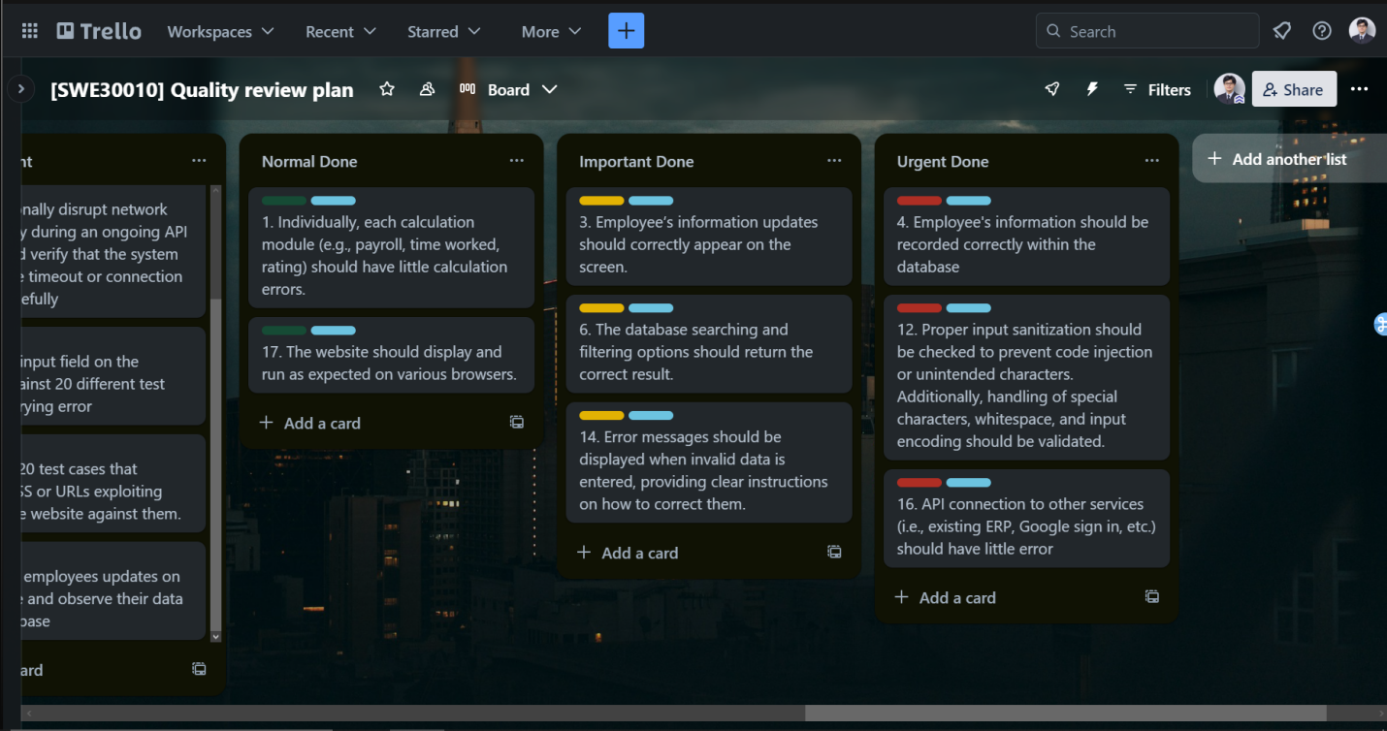Figure 1.1: Plan for each quality*

1. **Evidence & Report**

**Evidence**

**Group 1: Display and record**

**Quality 1**: Individually, each calculation module (e.g., payroll, time worked, rating) should have little calculation errors.

**Testing measure**: Insert 50 rows of employees with varying degrees of different parameters to observe whether the calculation function is correctly configured.

Original Data

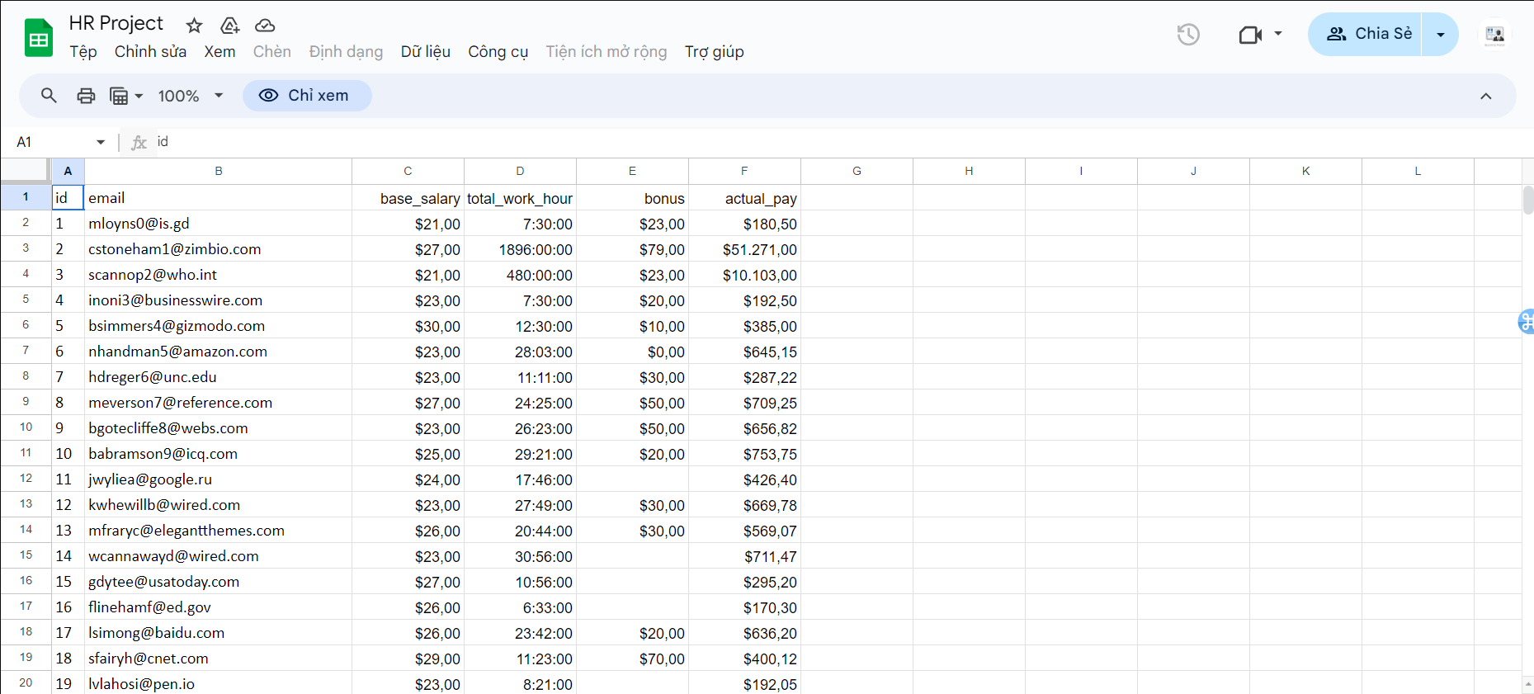

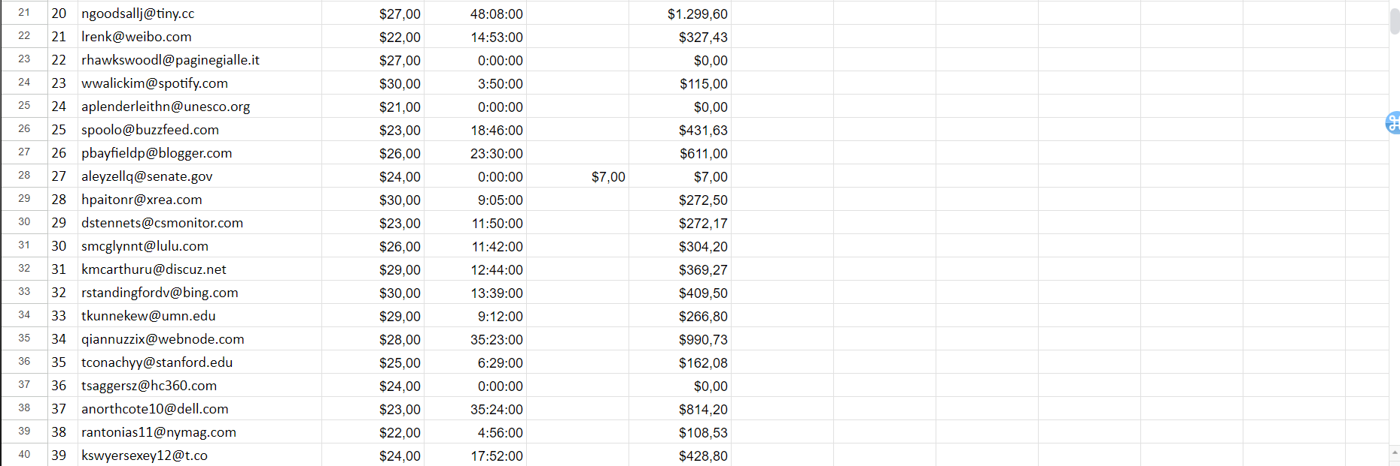

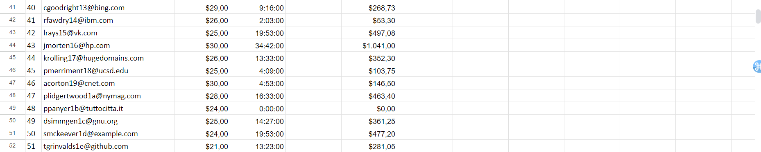

*Figure 2.1, 2.2, 2.3: 50 Original Rows*

After testing

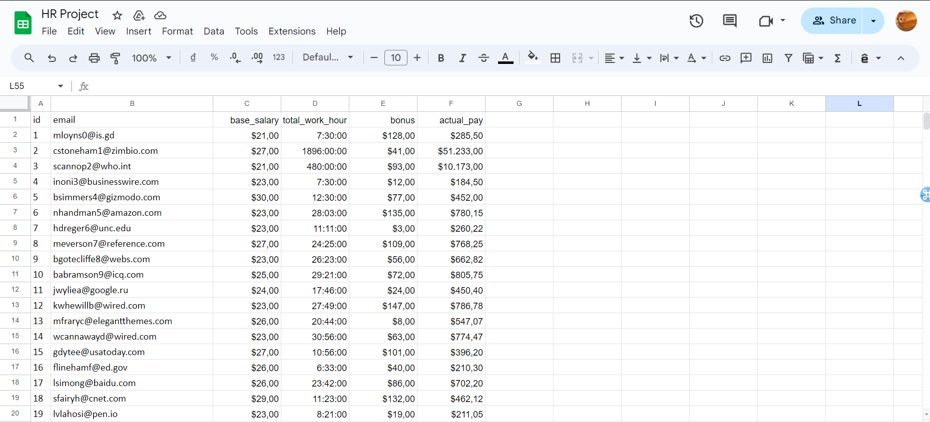

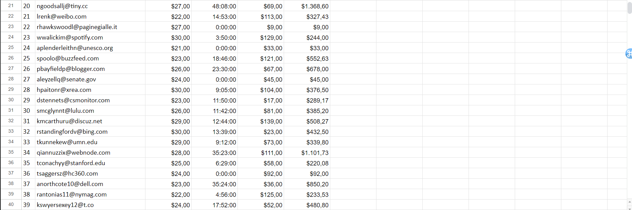

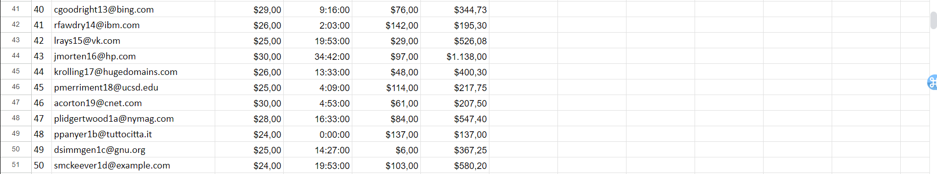

*Figure 2.1, 2.2, 2.3: 50 Post-tested Rows*

We employed our database as our calculation module as well, we used the following formula to calculate our employee’s pay:

=(((LEFT(D2 ; FIND(":"; D2) - 1))+(MINUTE(D2)/60))*C2)+E2

After testing, all the rows have been calculated correctly and this quality passed our defined threshold.

**Quality 3**: Employee’s information updates should correctly appear on the screen.

**Testing measure**: Verify the displayed information on the website against the database.

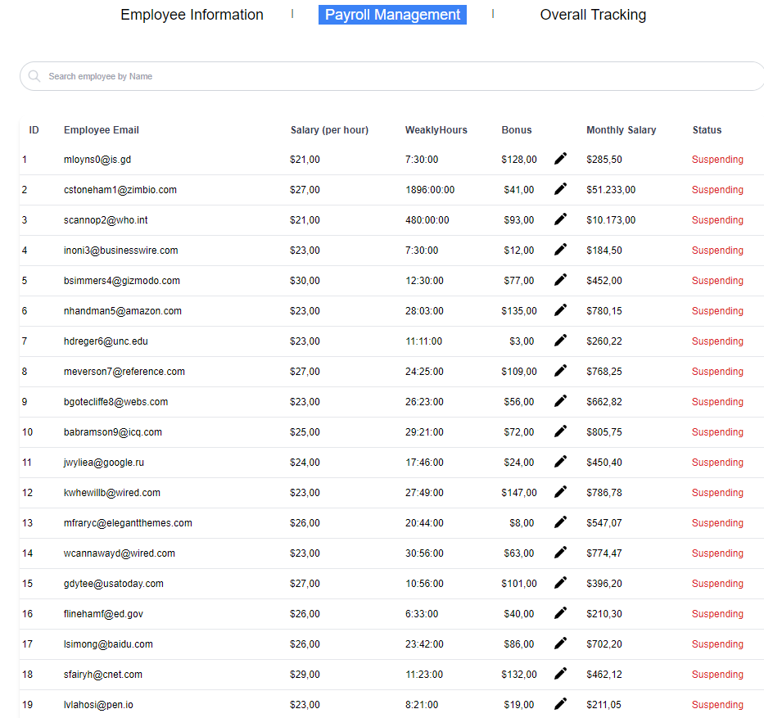

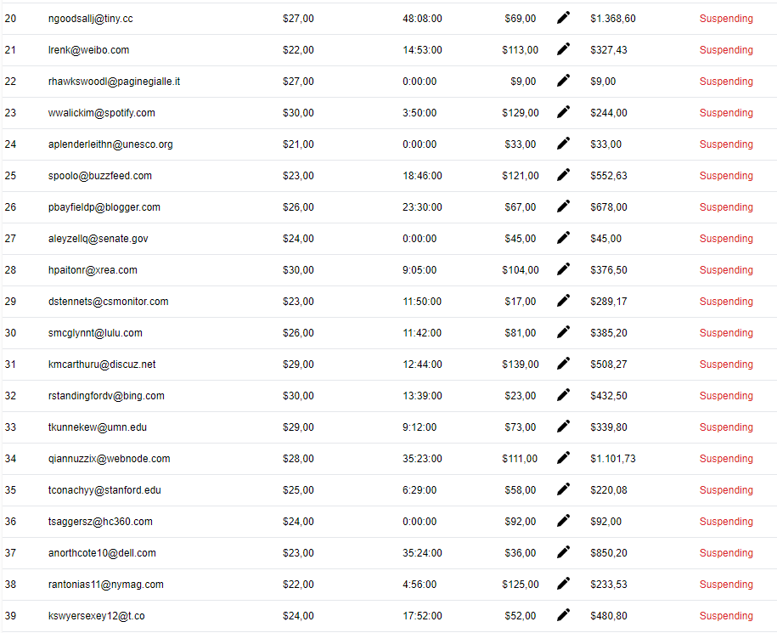

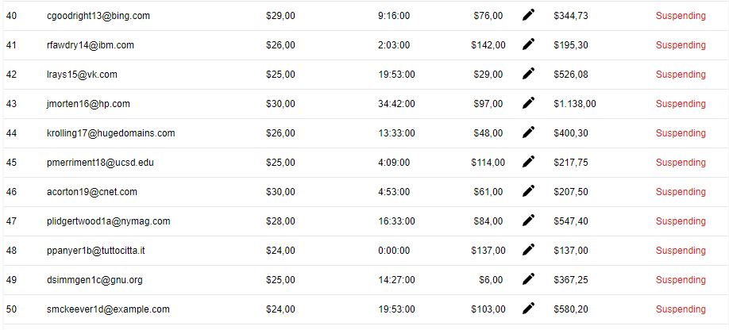

*Figure 2.4, 2.5, 2.6: Displaying of payroll on website*

With the database’s pay calculated, we can take a look at the website to see how it displayed the data, and as can be seen, all the 50 rows have been updated correctly.

Employees’ information has also been correctly displayed in the employee’s management tab:

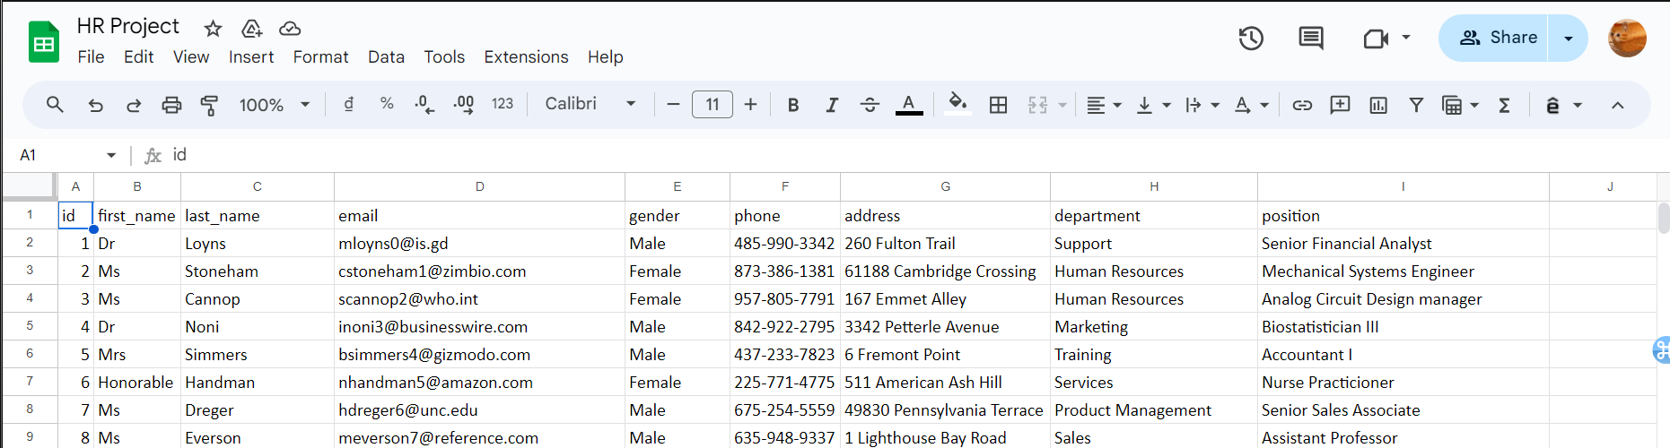

*Figure 2.7: Employee’s information in Database*

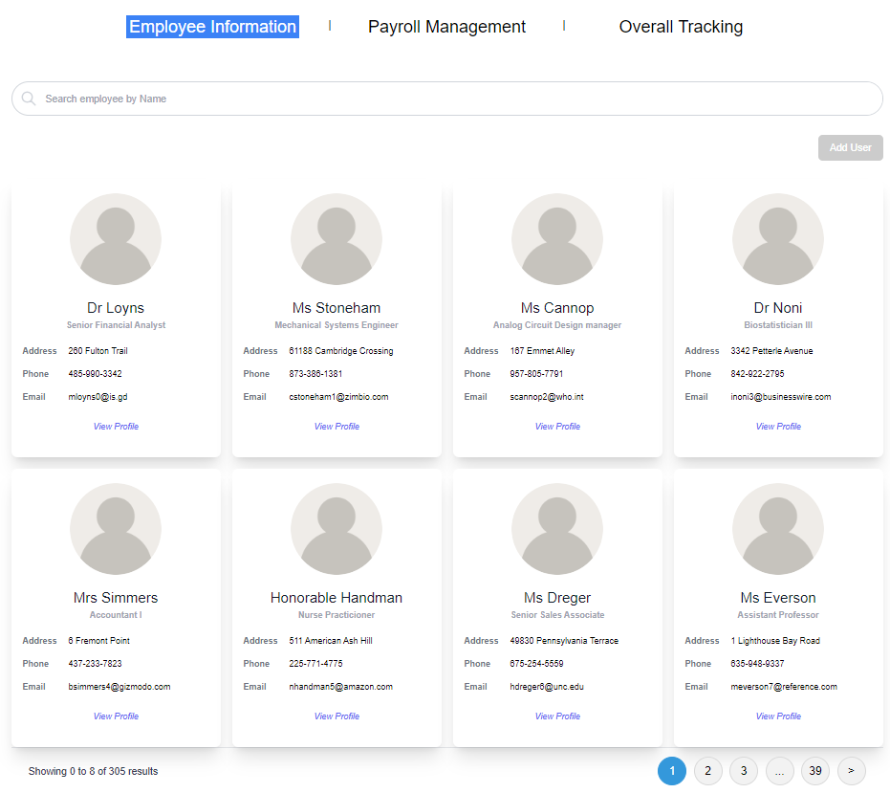

*Figure 2.8: Employee’s information on Website*

With the website displaying the correct information within the database, this quality passed our benchmark.

**Quality 4**: Employee's information should be recorded correctly within the database.

**Testing measure**: Make 20 employees updates on the website and observe their data in the database.

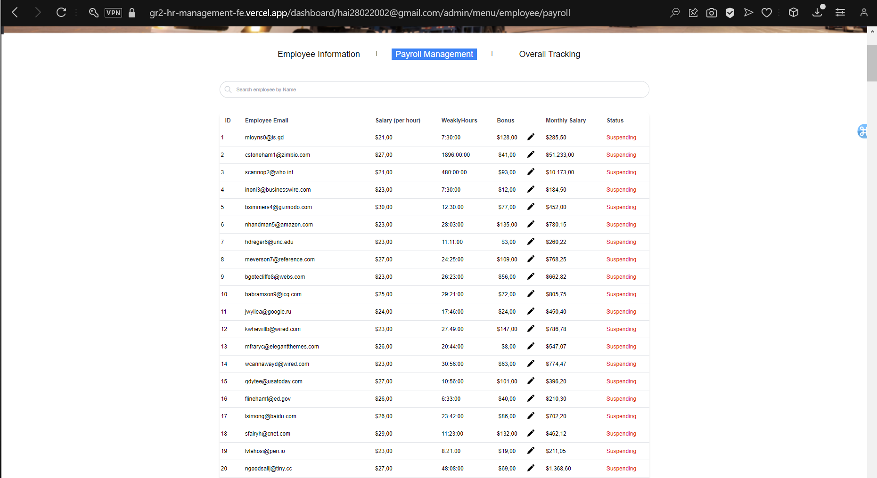

*Figure 2.9: First 20 employees*

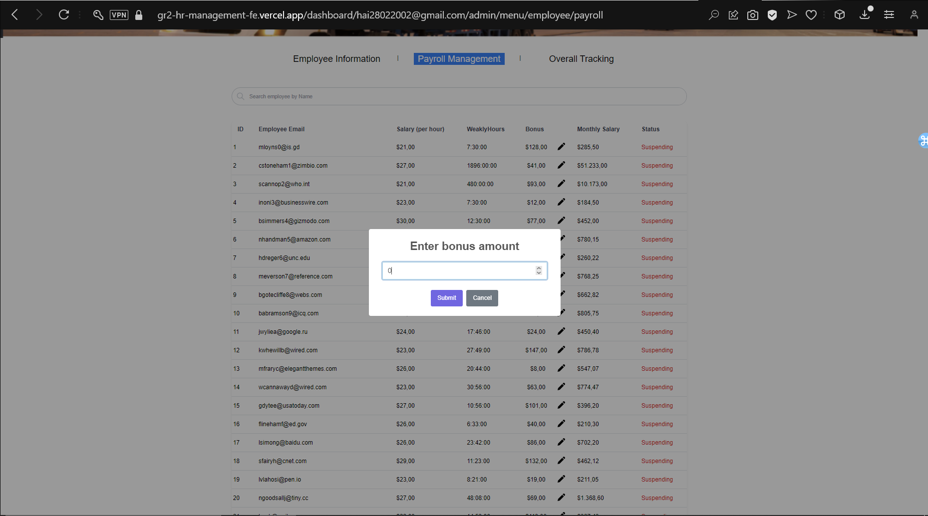

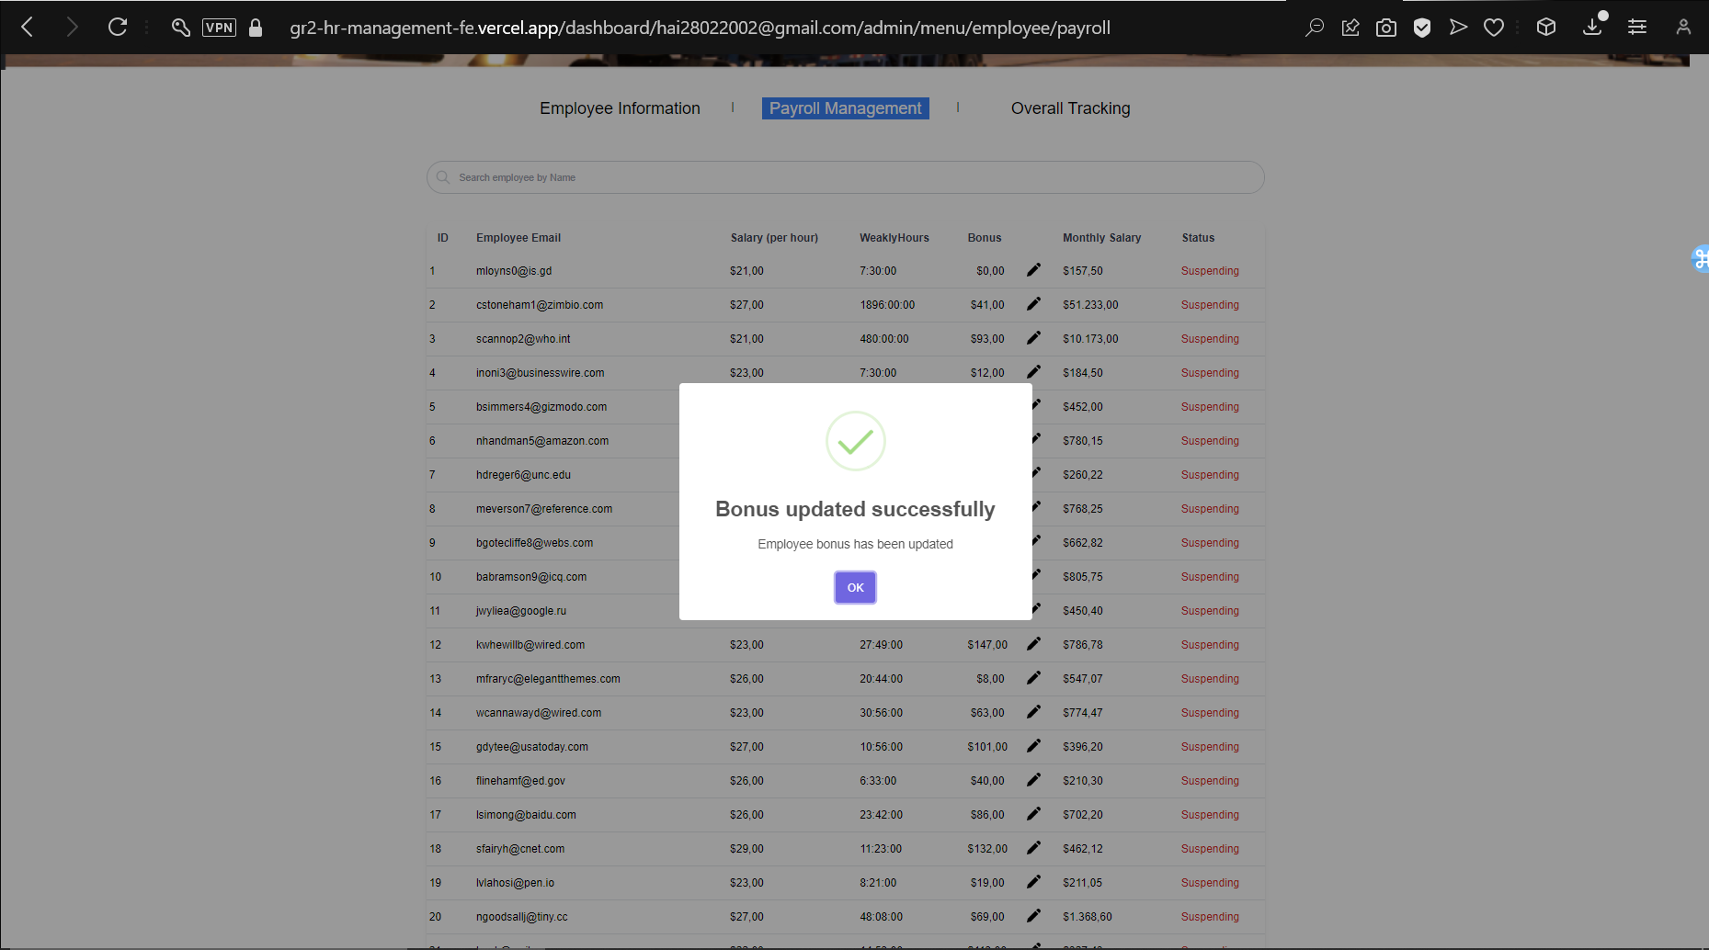

*Figure 2.10, 2.11: Update, Confirmation Prompt and Amount*

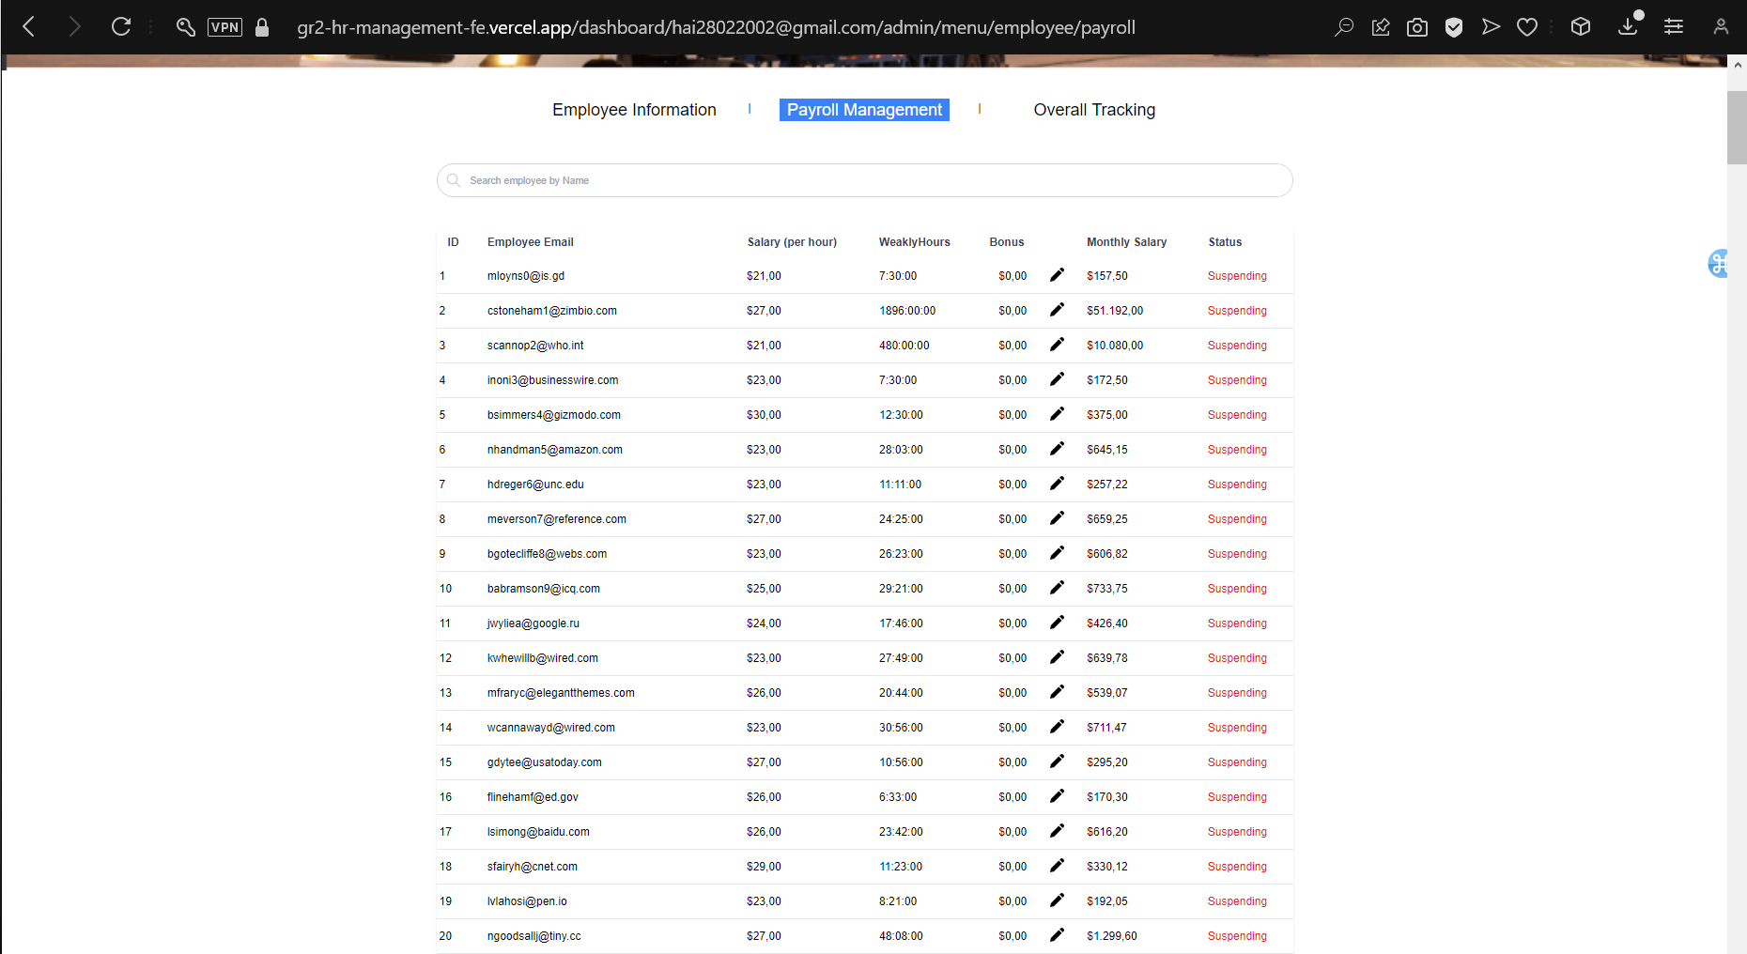

*Figure 2.12: After update on Website*

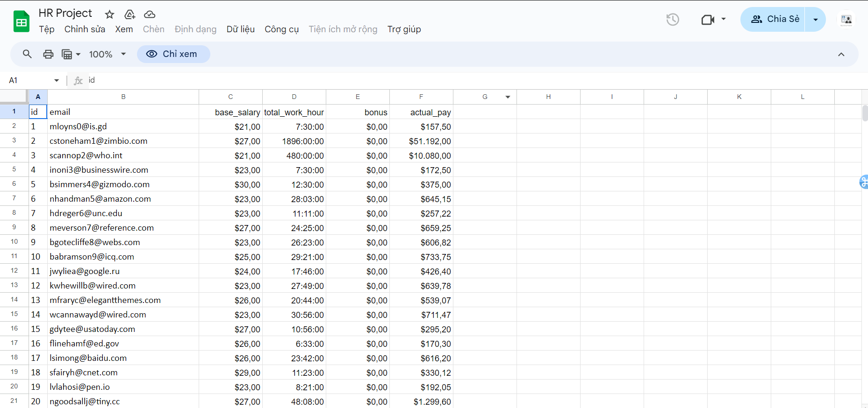

*Figure 2.13: Information in Database*

The information written on the website matches that of the database, hence, the accuracy is correct, and this quality passed our benchmark.

**Quality 17**: The website should display and run as expected on various browsers.

**Testing measure**: Run the HRM website on Opera, Chrome, Coc Coc, Firefox, Brave, and Edge, and note any differences or issues.

**Opera**:

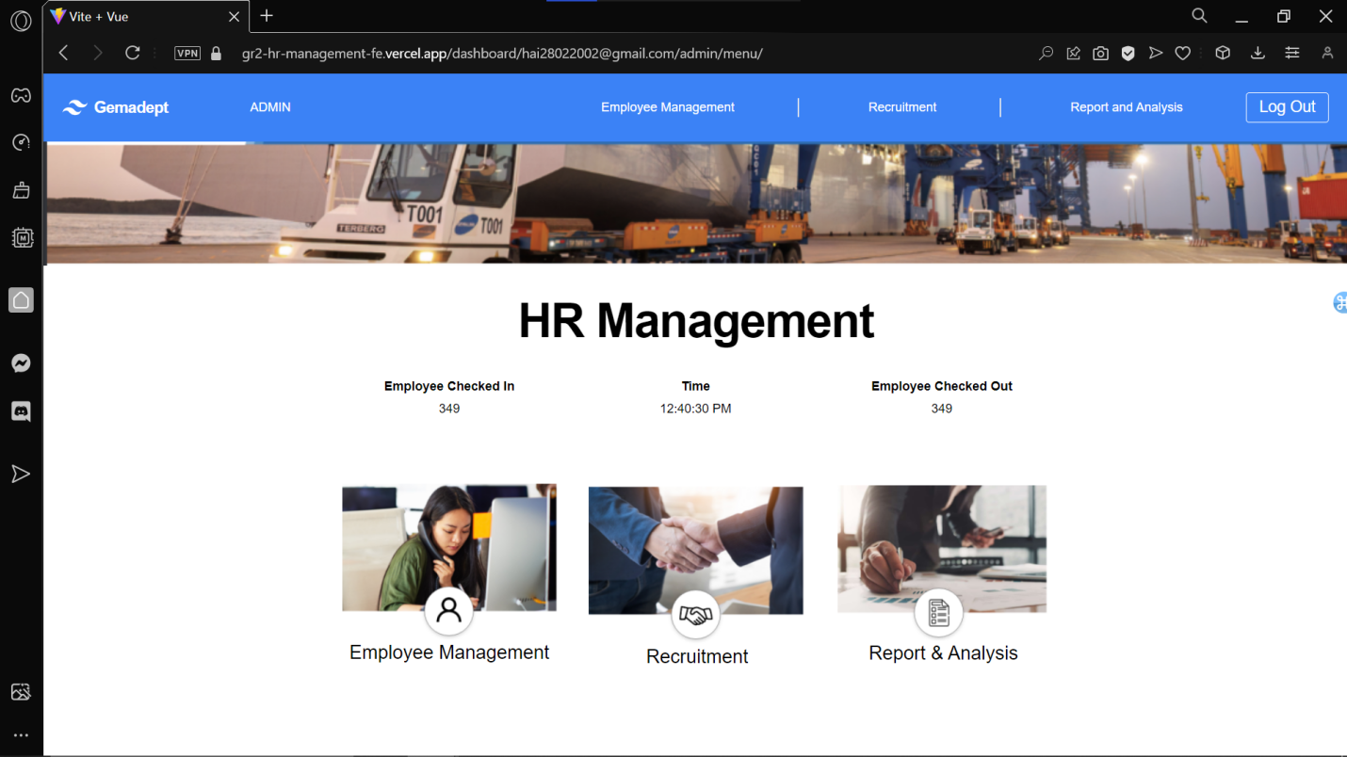

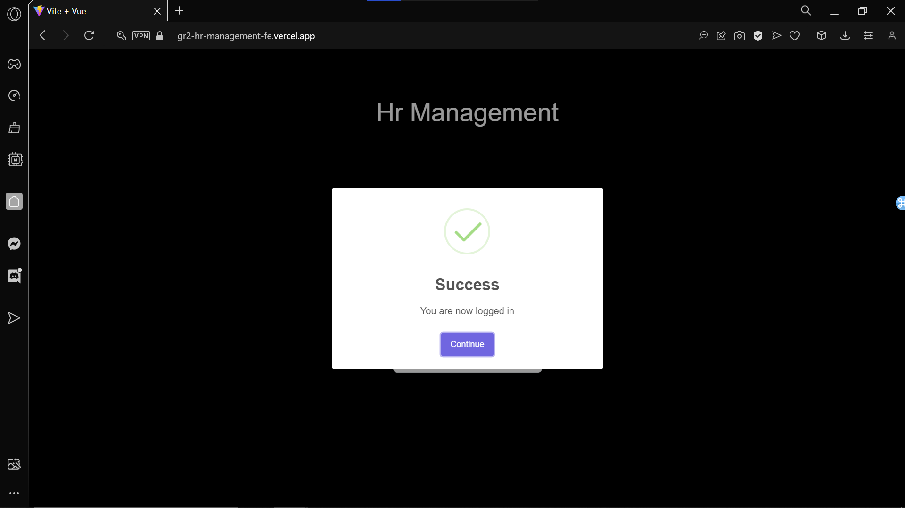

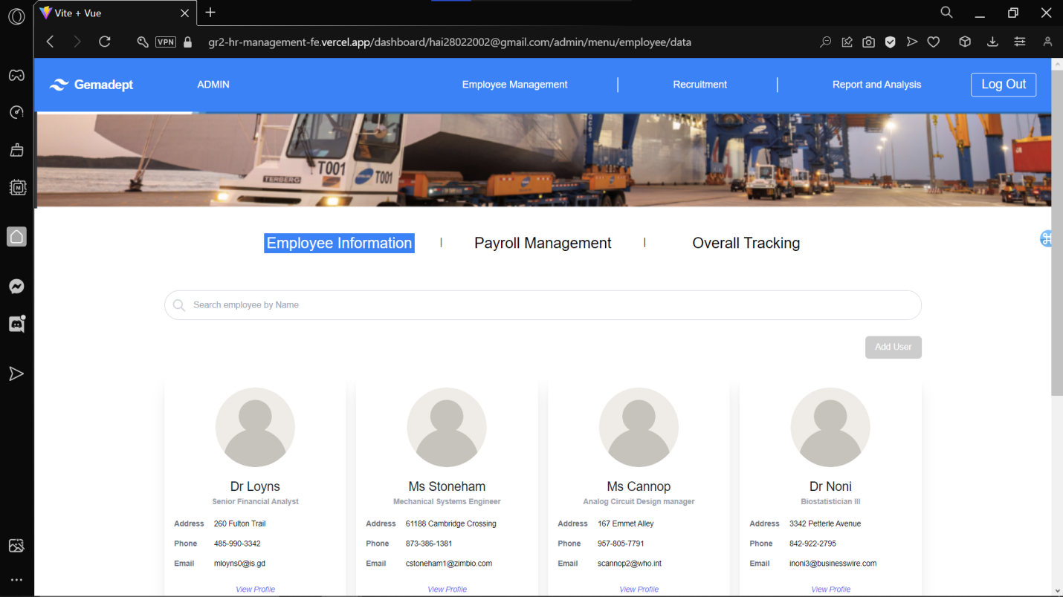

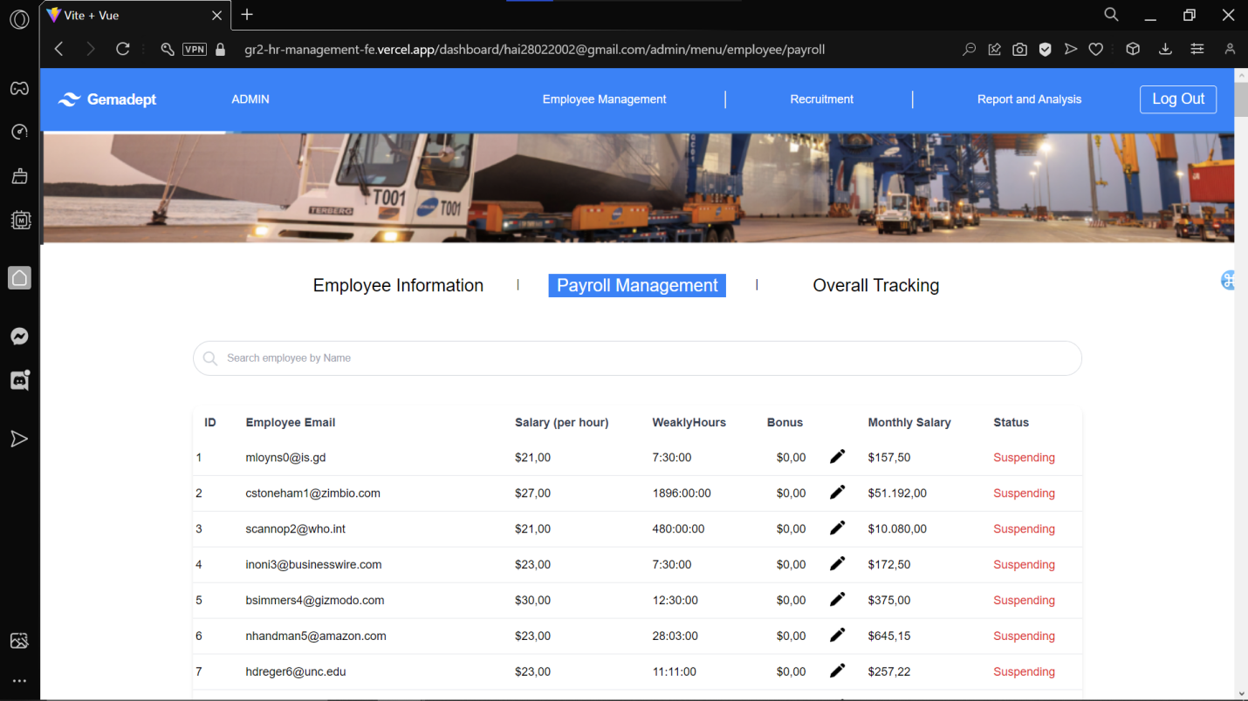

*Figure 2.14 – 2.17: Website on Opera Browser*

**Google Chrome**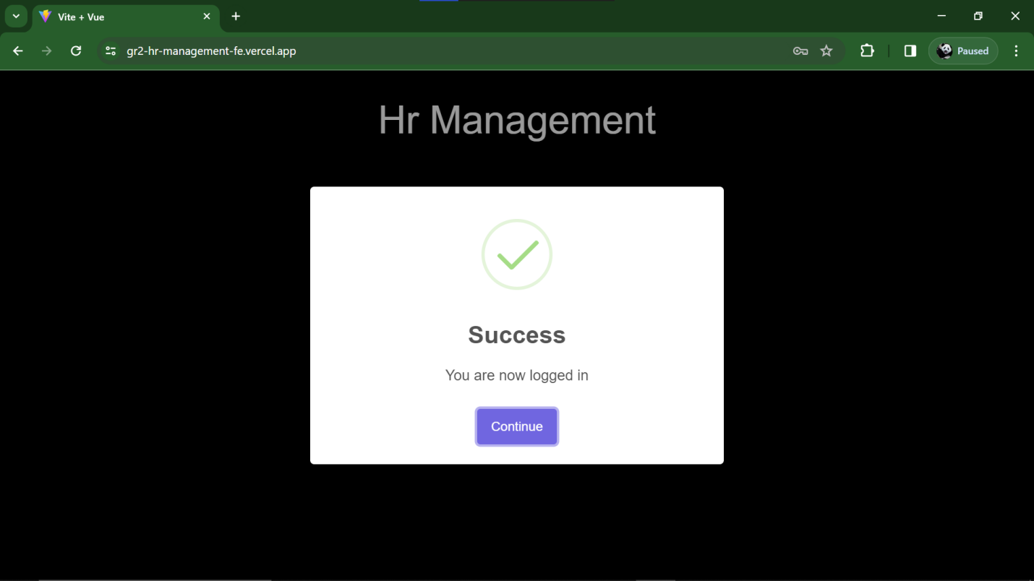

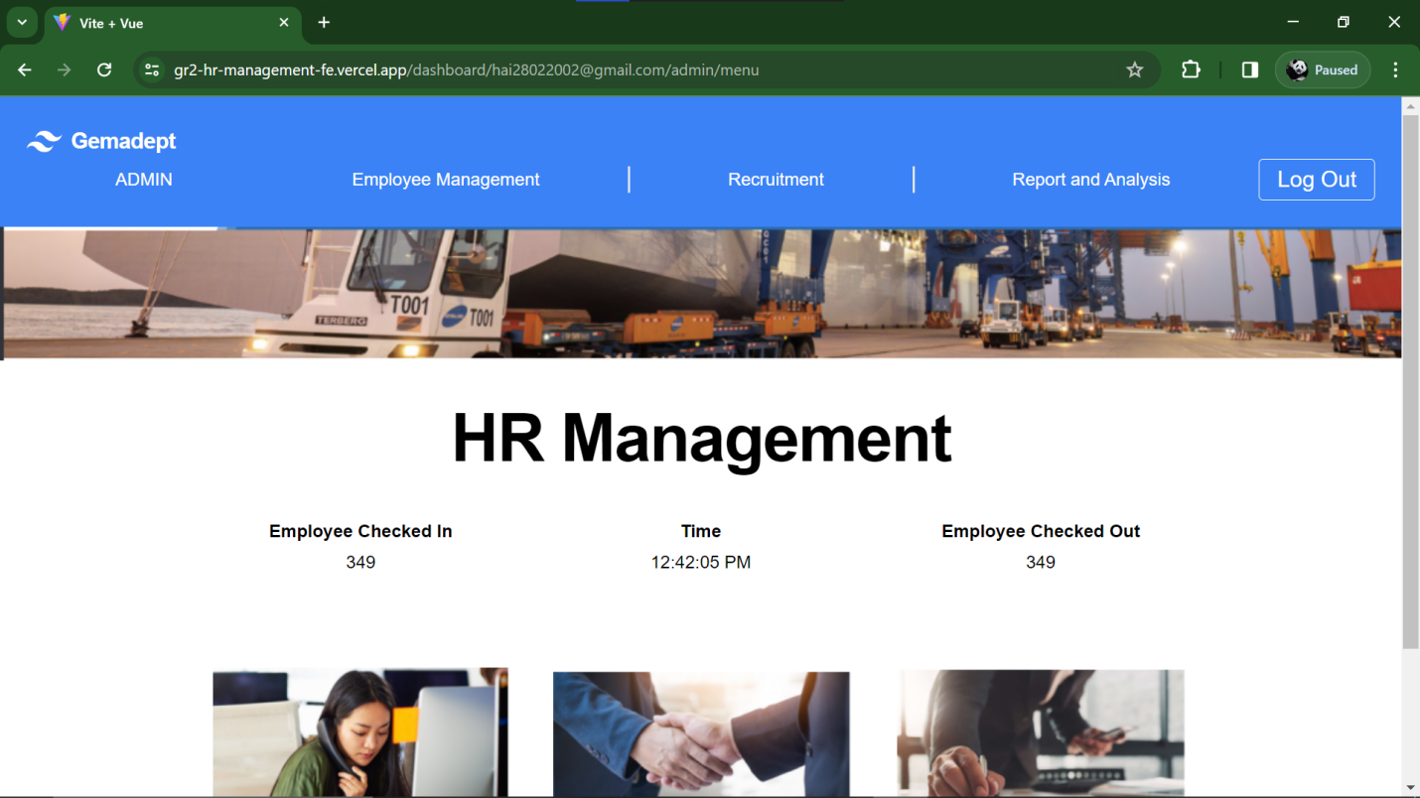

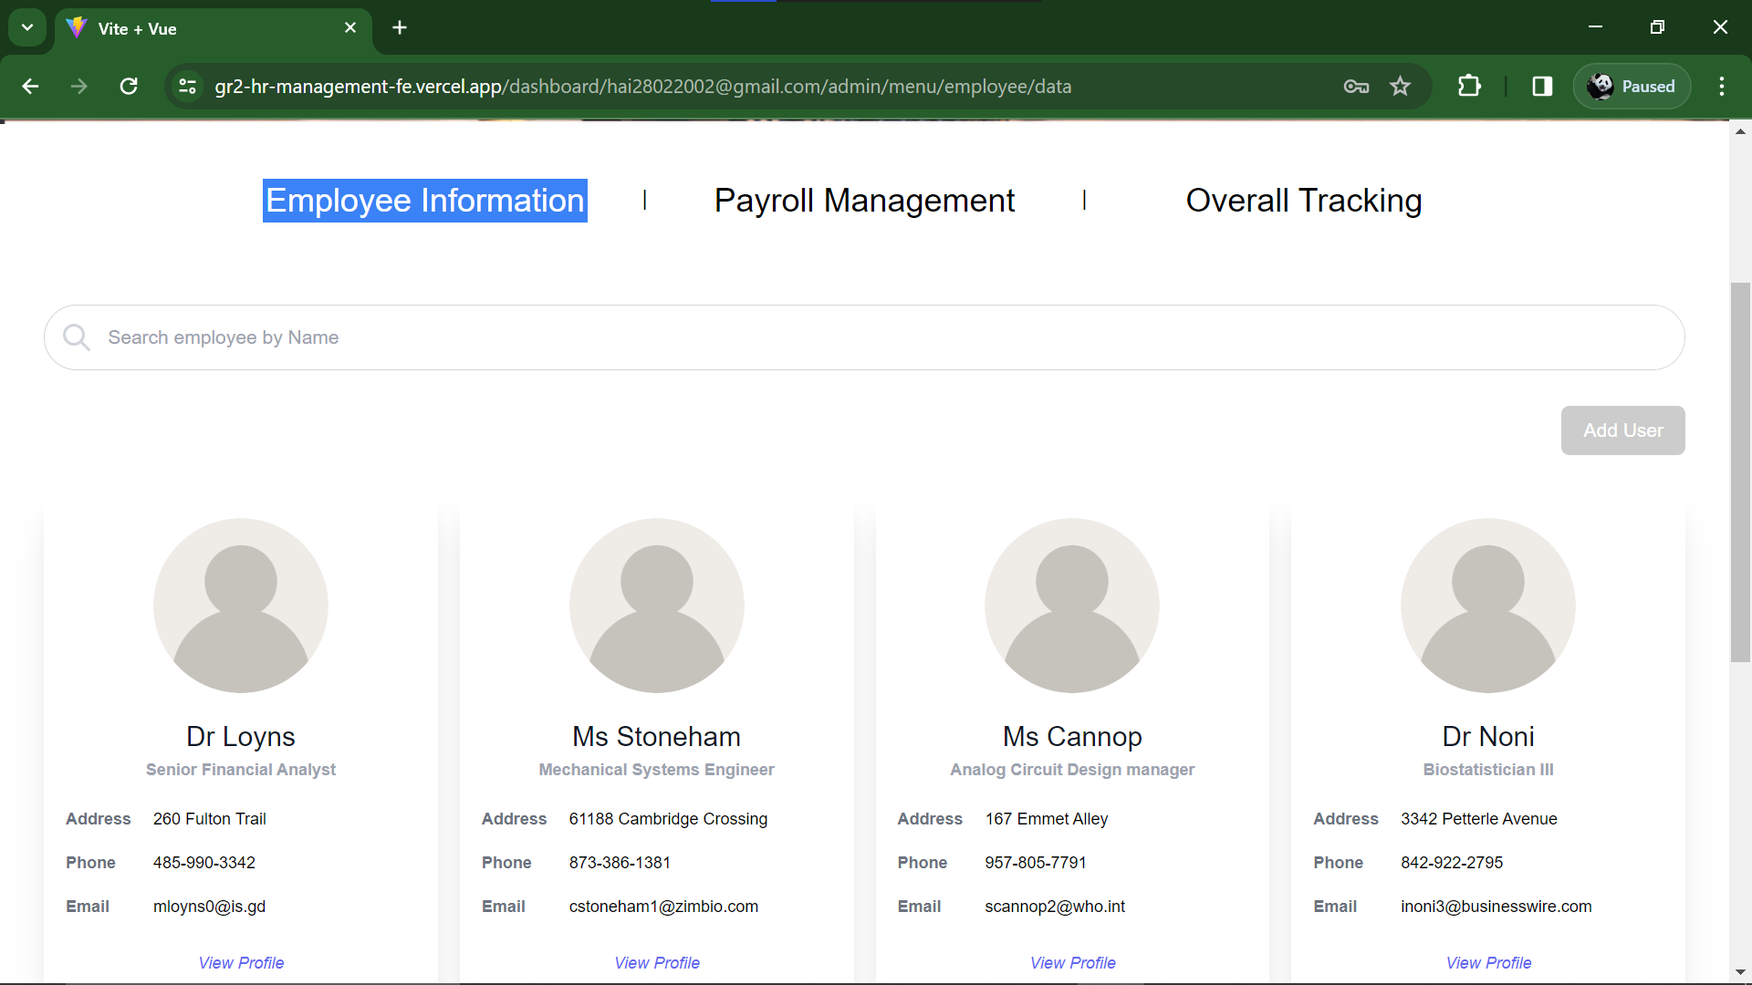

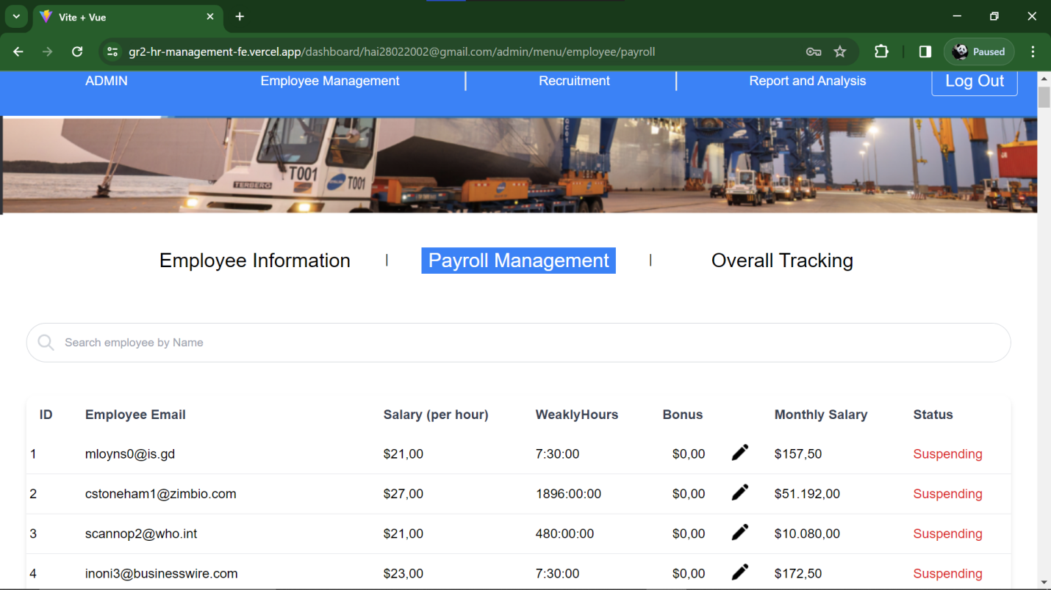

*Figure 2.18 – 2.21: Website on Google Chrome*

**Coc Coc**:

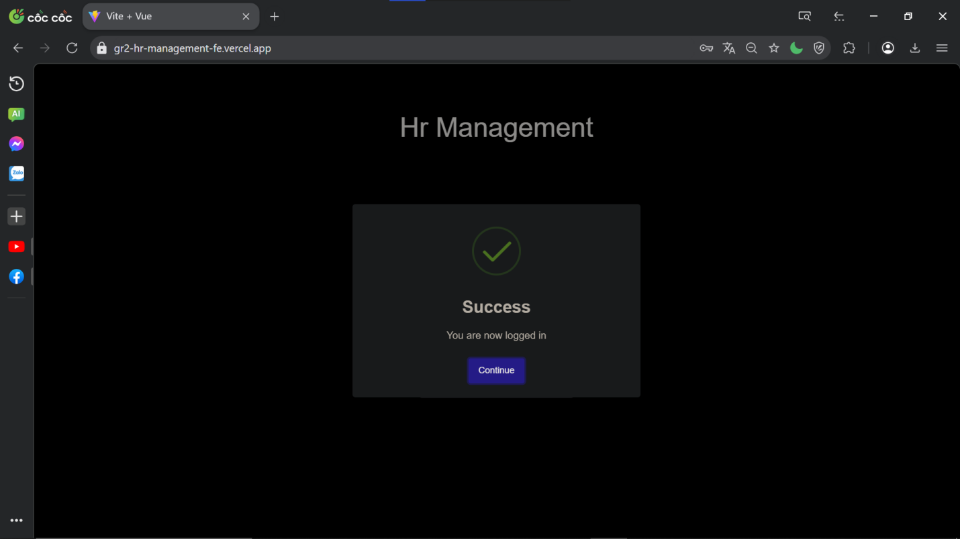

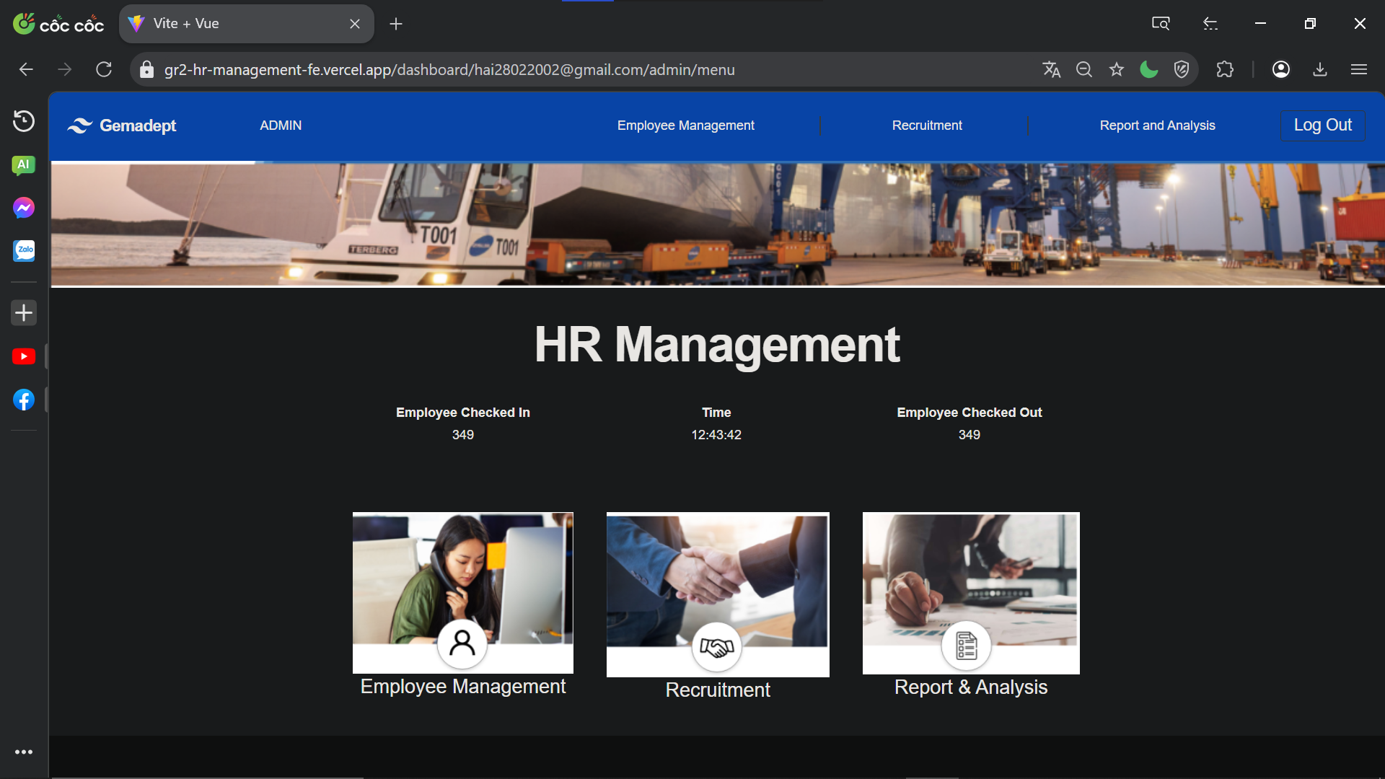

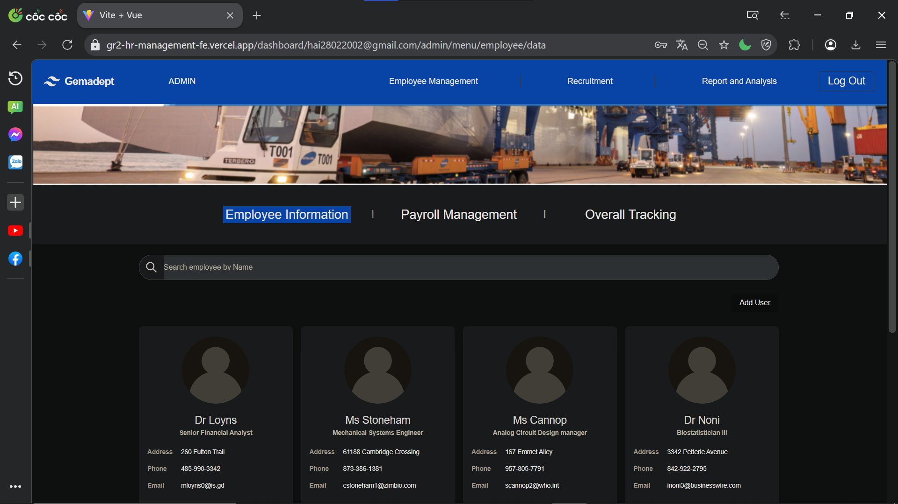

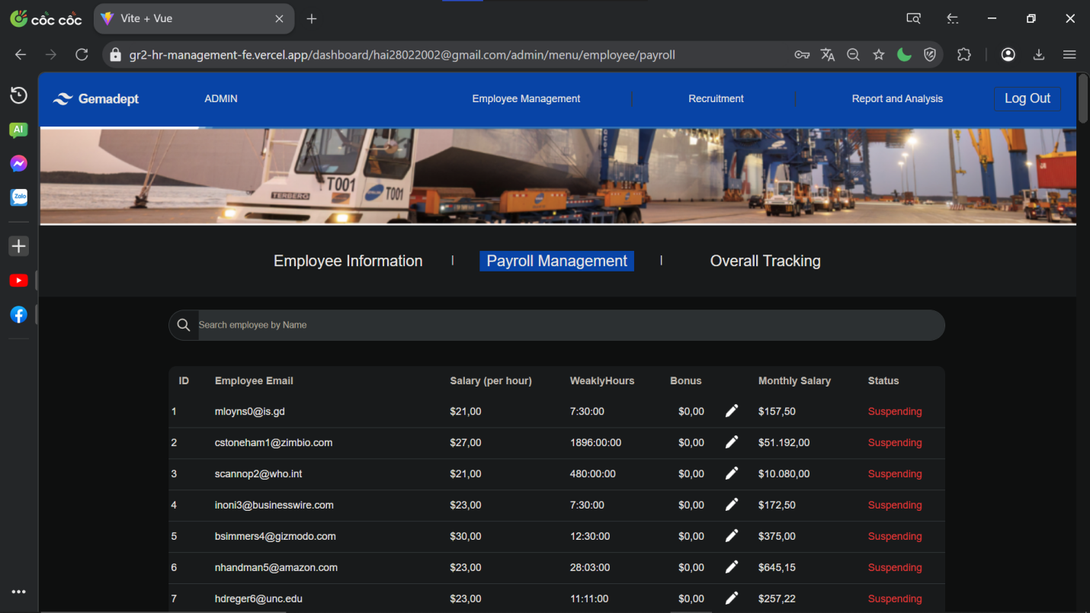

*Figure 2.22 – 2.25: Website on Google Chrome*

**Firefox:**

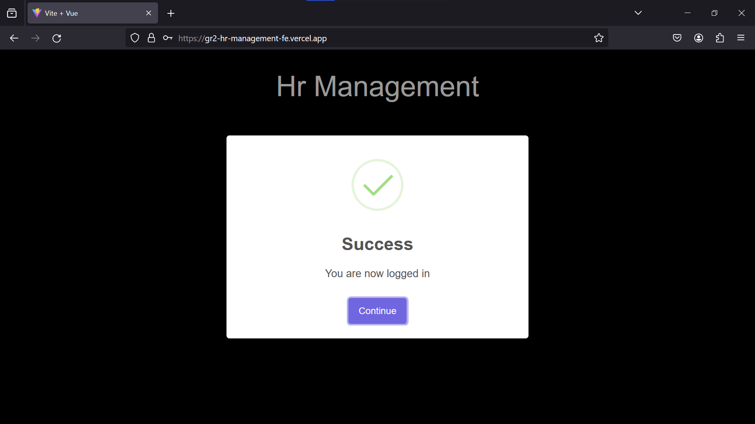

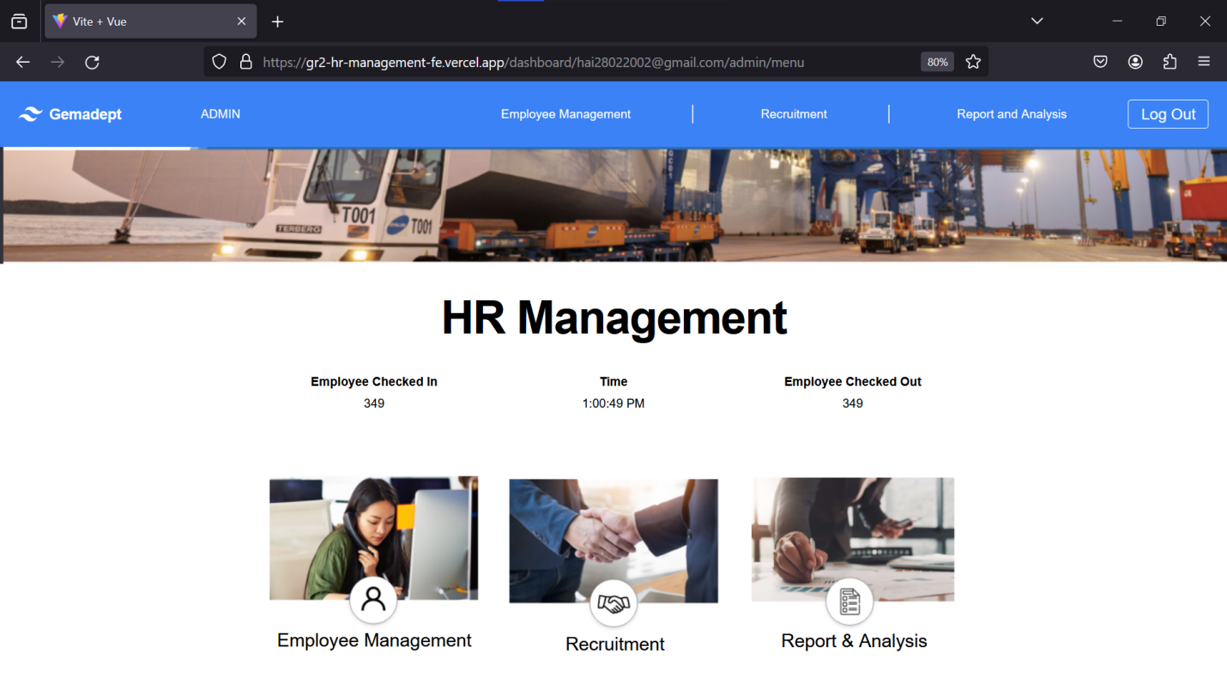

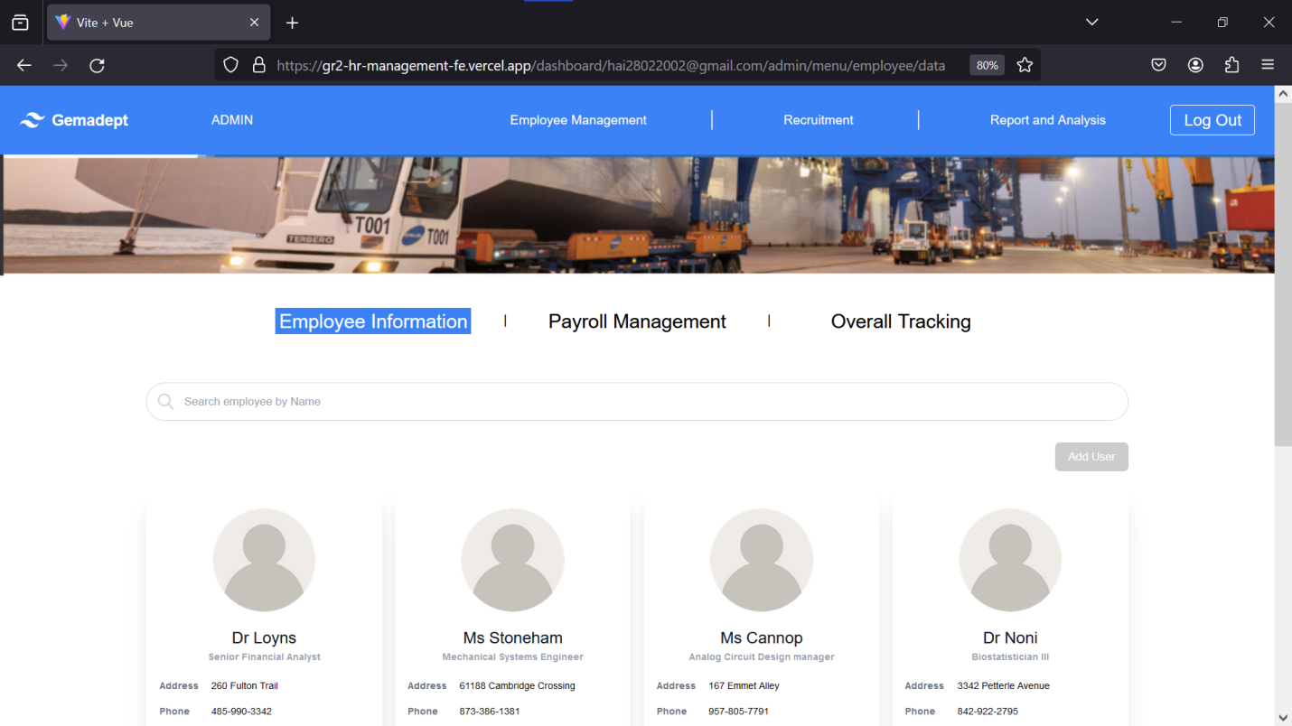

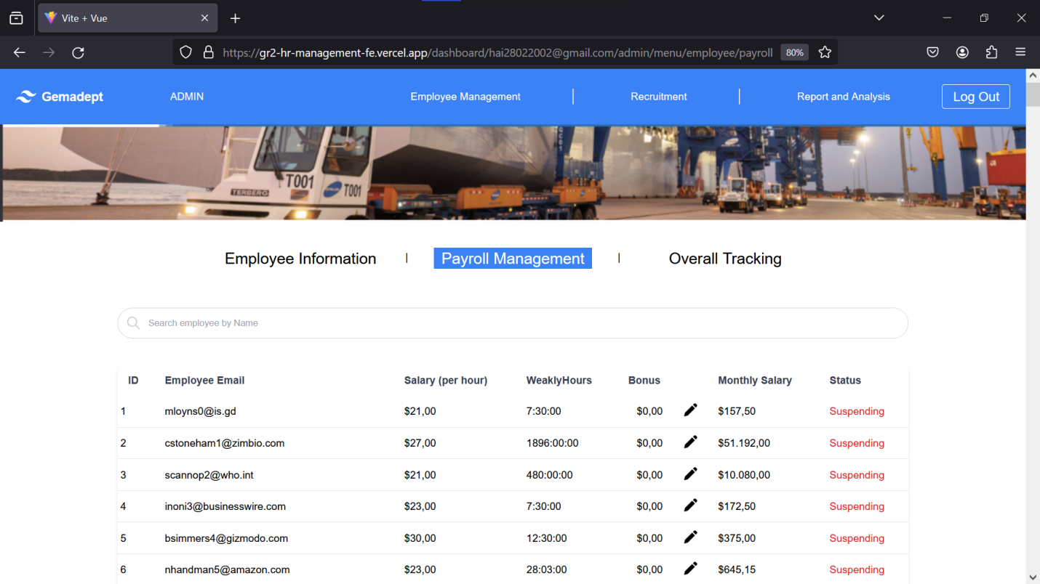

*Figure 2.26 – 2.29: Website on Firefox*

**Brave:**

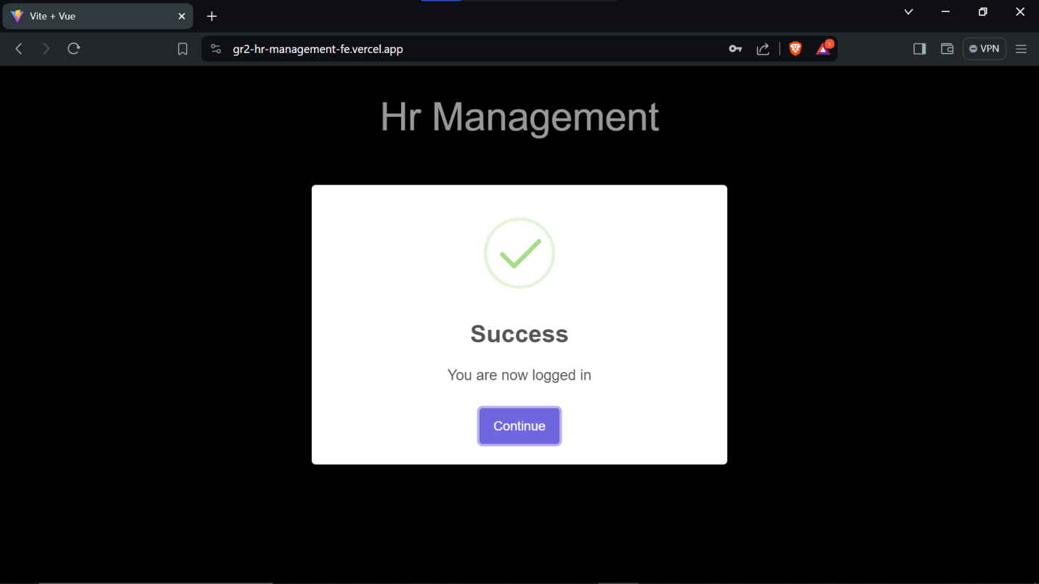

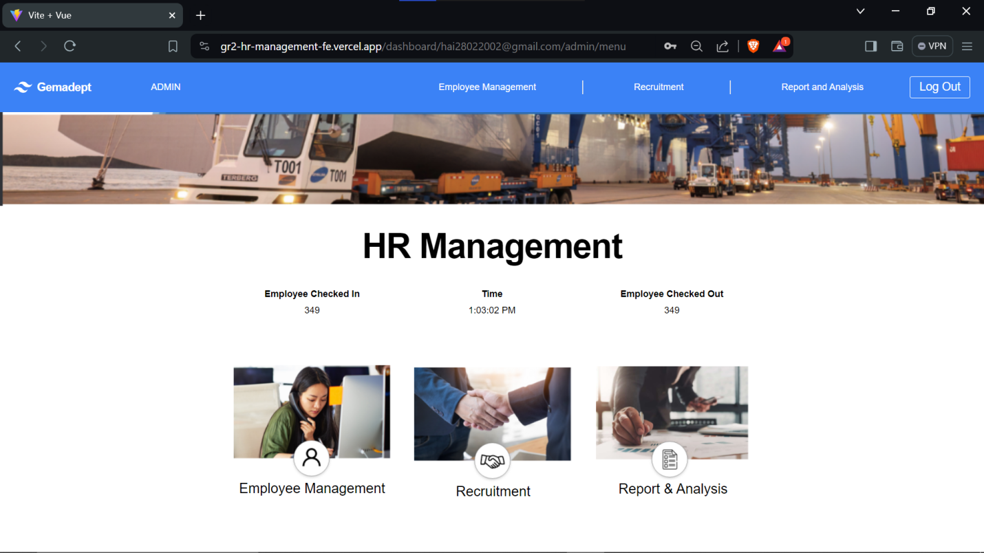

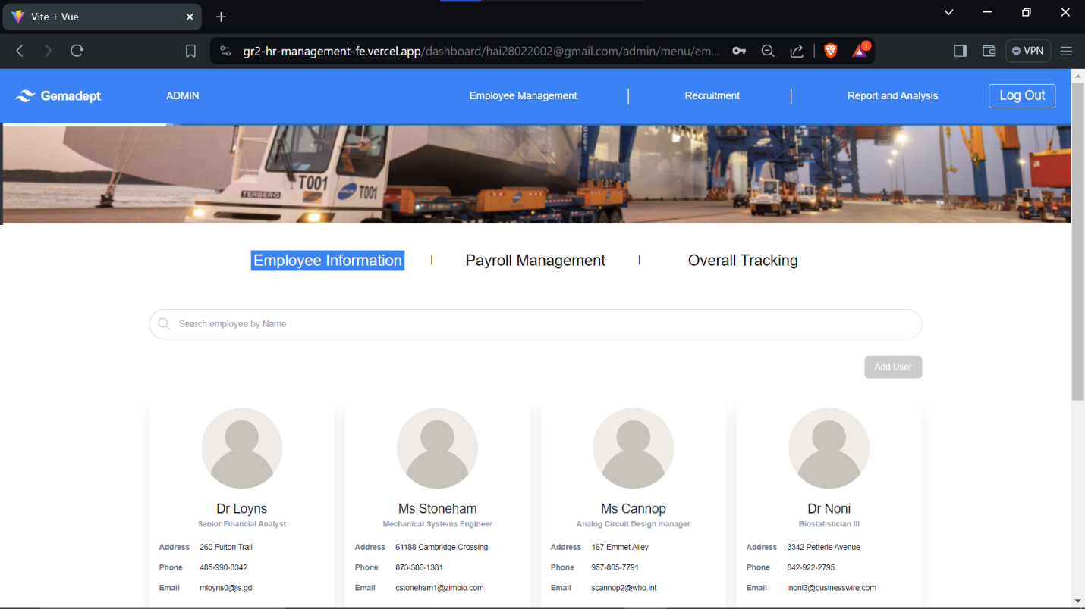

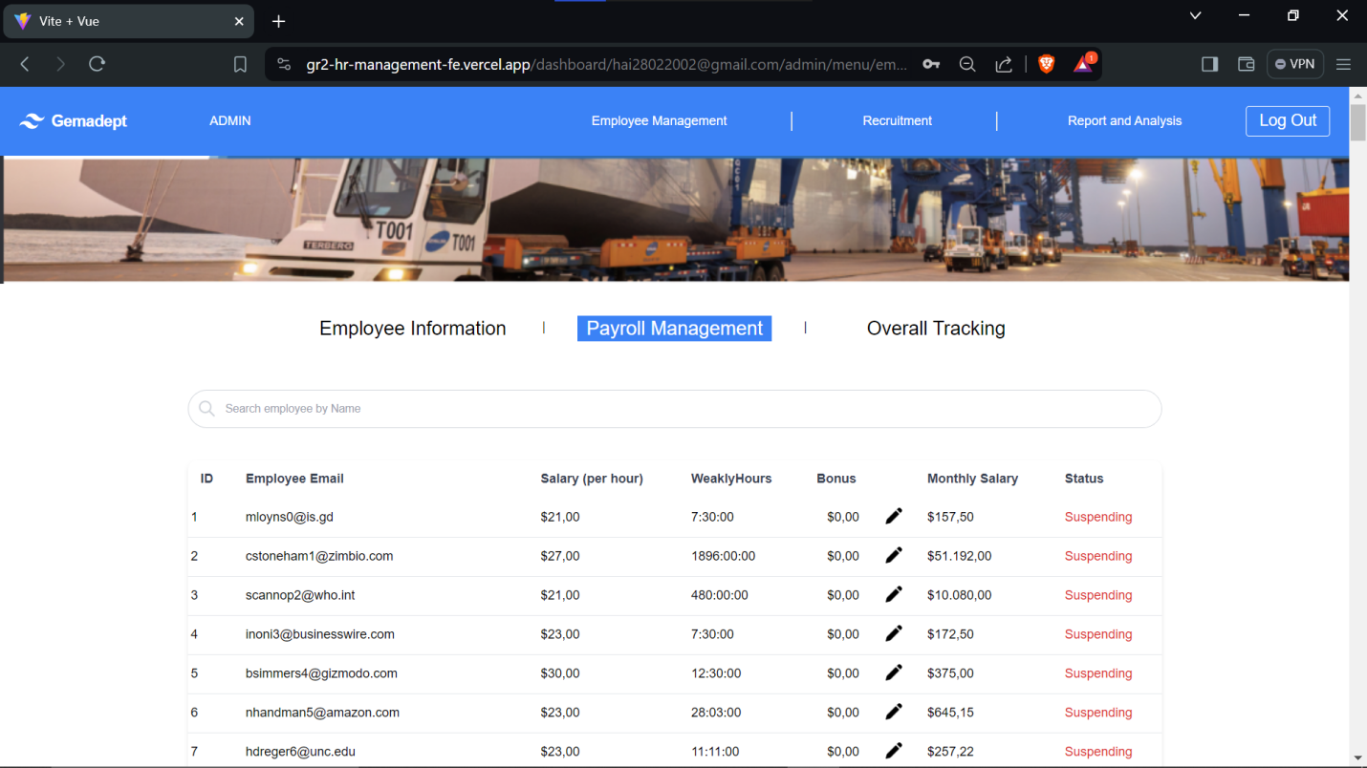

*Figure 2.30 – 2.33: Website on Brave*

**Edge**:

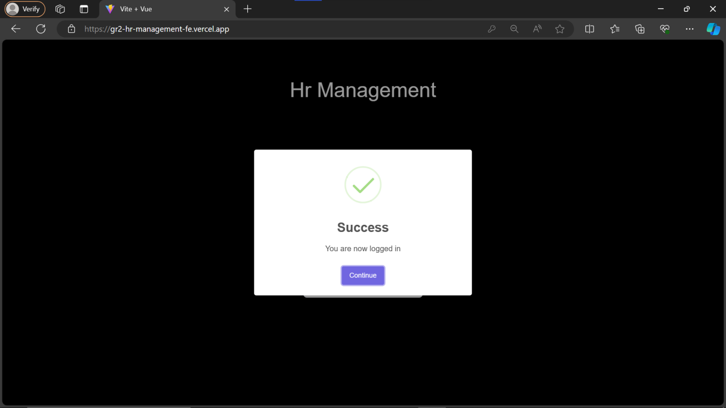

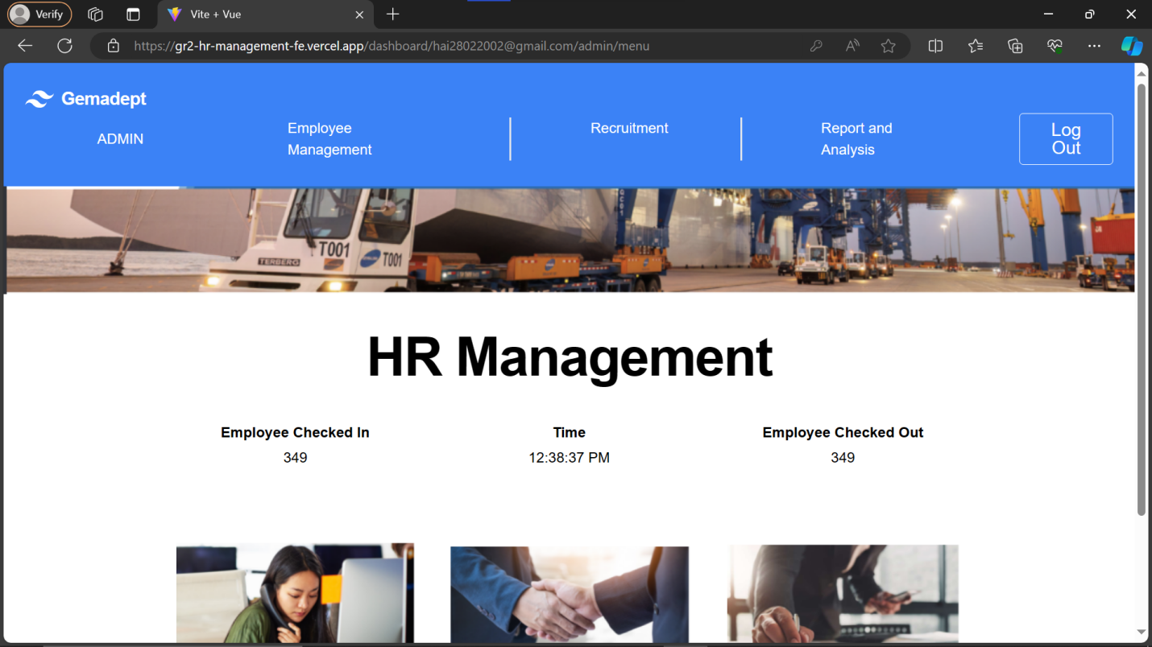

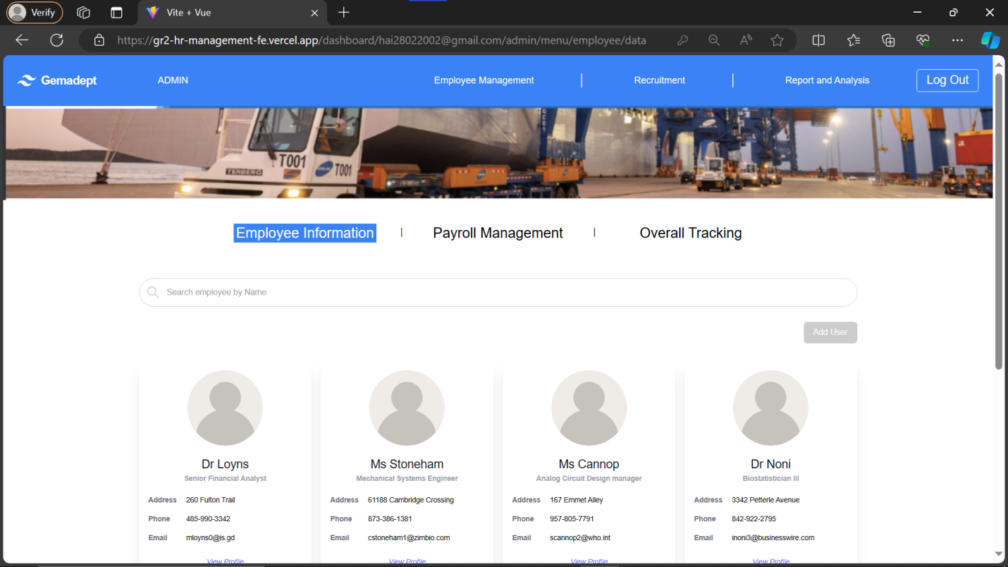

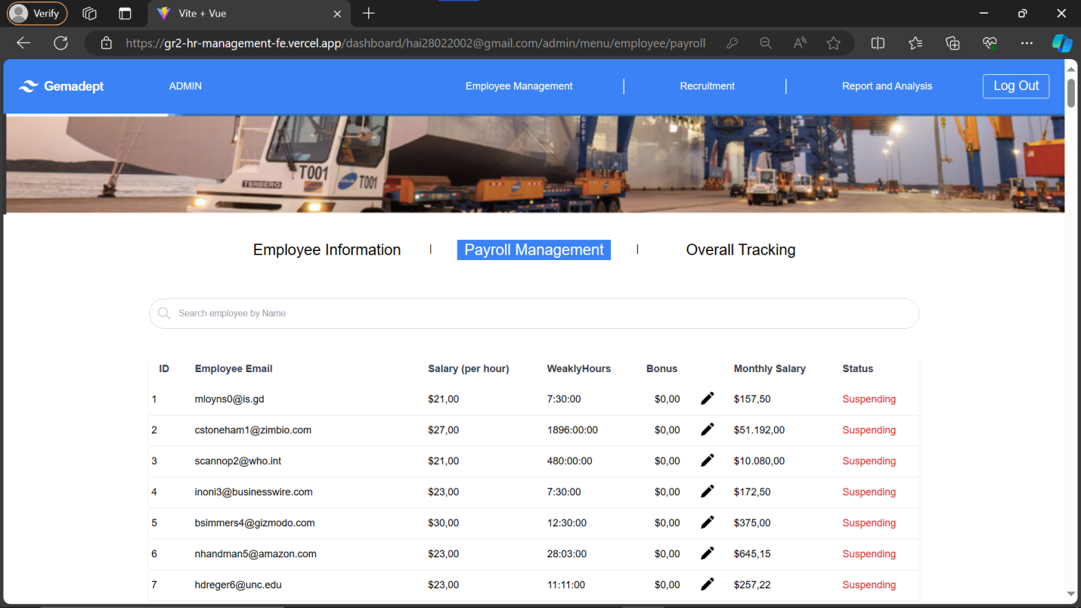

*Figure 2.34 – 2.37: Website on Edge*

We tested login in and other tests on various browser and our website held itself well. Hence, this quality passed our benchmark.

**Group 2: Search and Input**

**Quality 6**: The database searching and filtering options should return the correct result.

**Testing measure**: Use the search function with a variety of keywords and random words to note the displayed information.

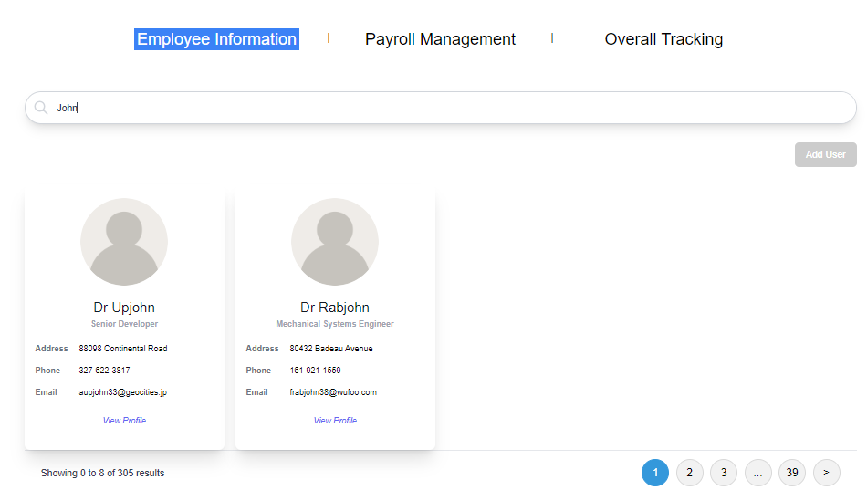

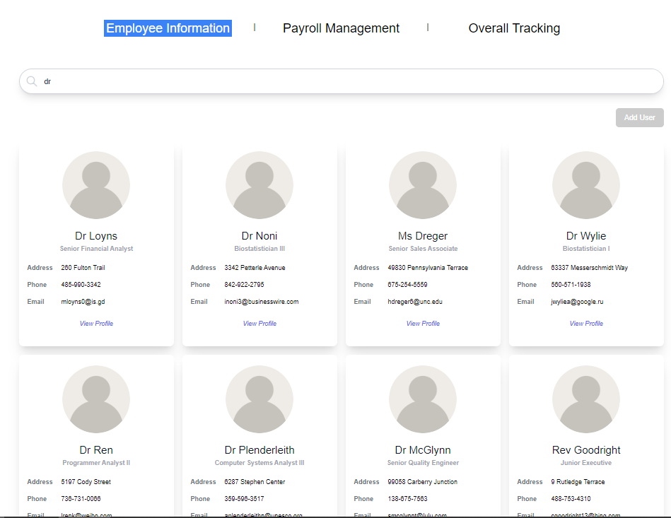

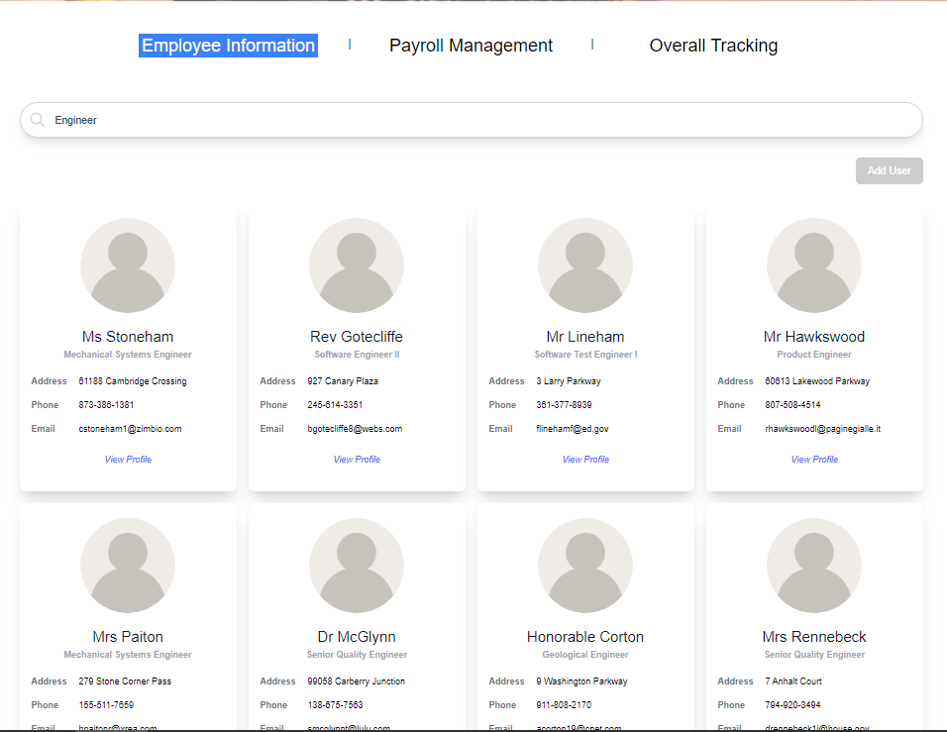

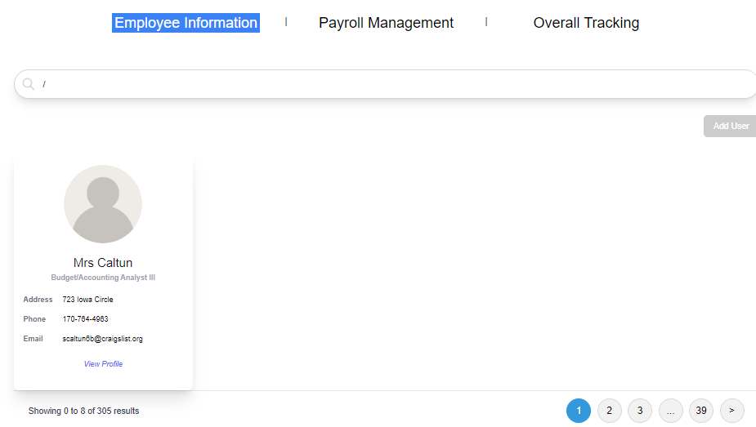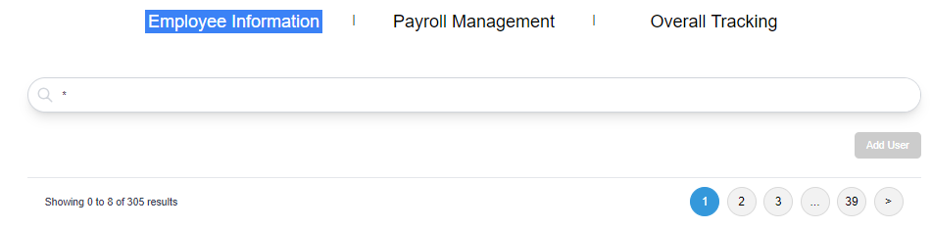

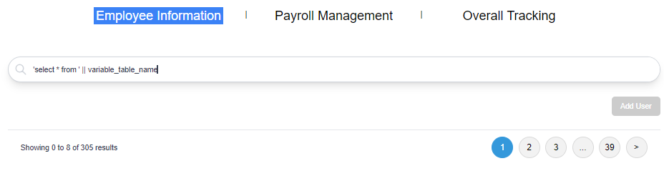

*Figure 2.38 – 2.43: Testing search query*

We tested the website’s query with a variety of input from words, names, to special characters, and as can be seen, the search returns accurate results and does not allow special characters, hence this quality passed our benchmark.

**Quality 12**: Proper input sanitization should be checked to prevent code injection or unintended characters. Additionally, handling of special characters, whitespace, and input encoding should be validated.

**Testing measure**: Test all input fields on the website against 20 different test cases of varying error.

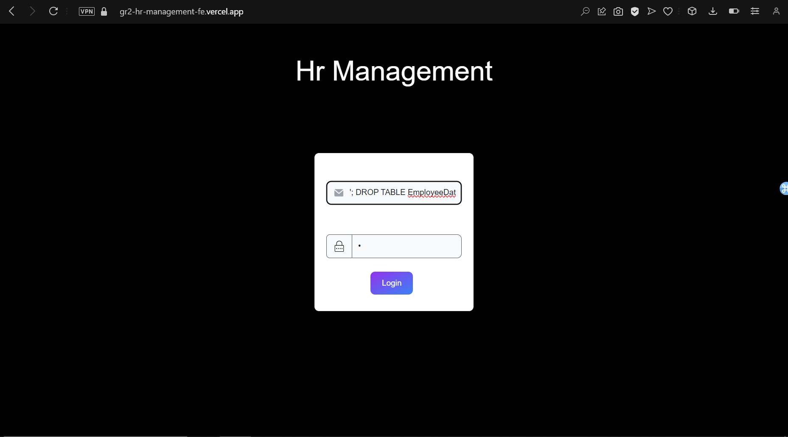

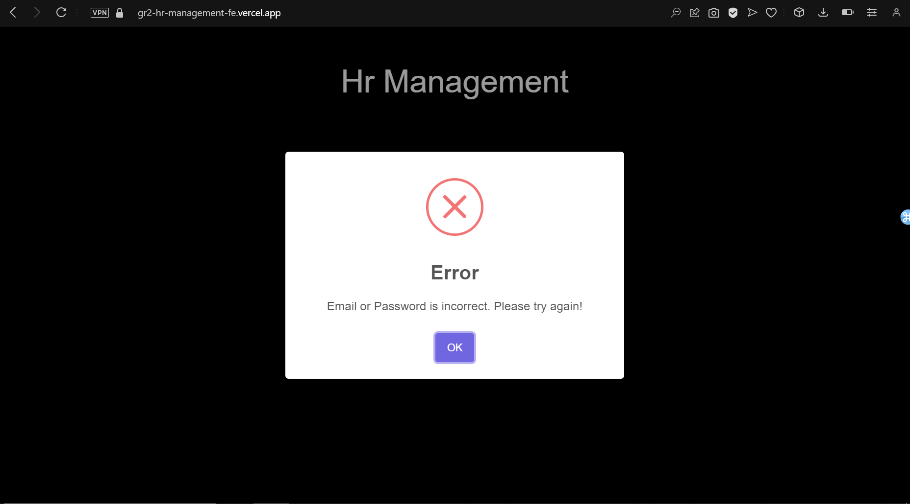

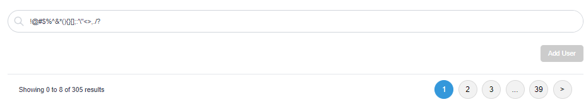

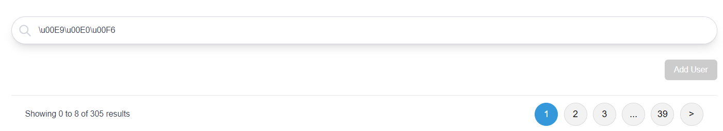

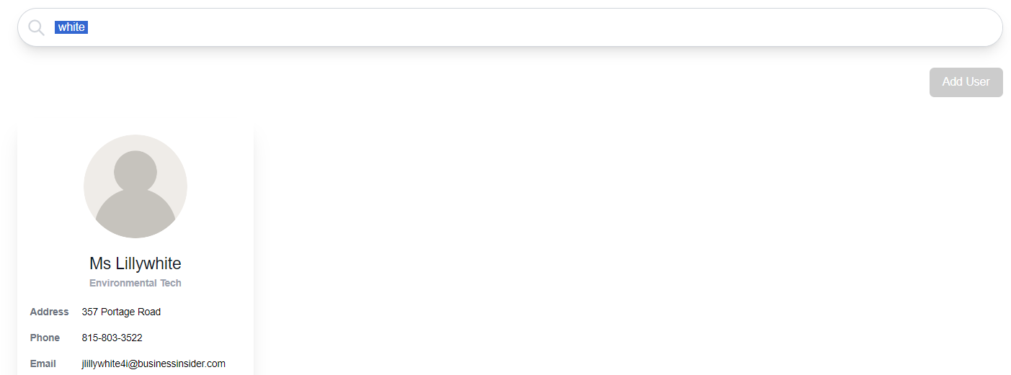

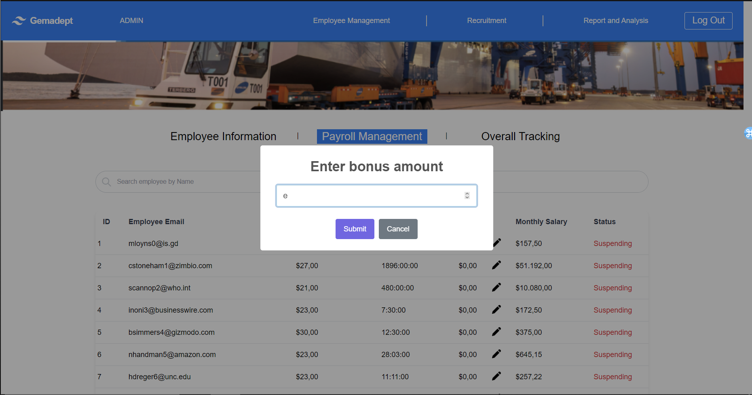

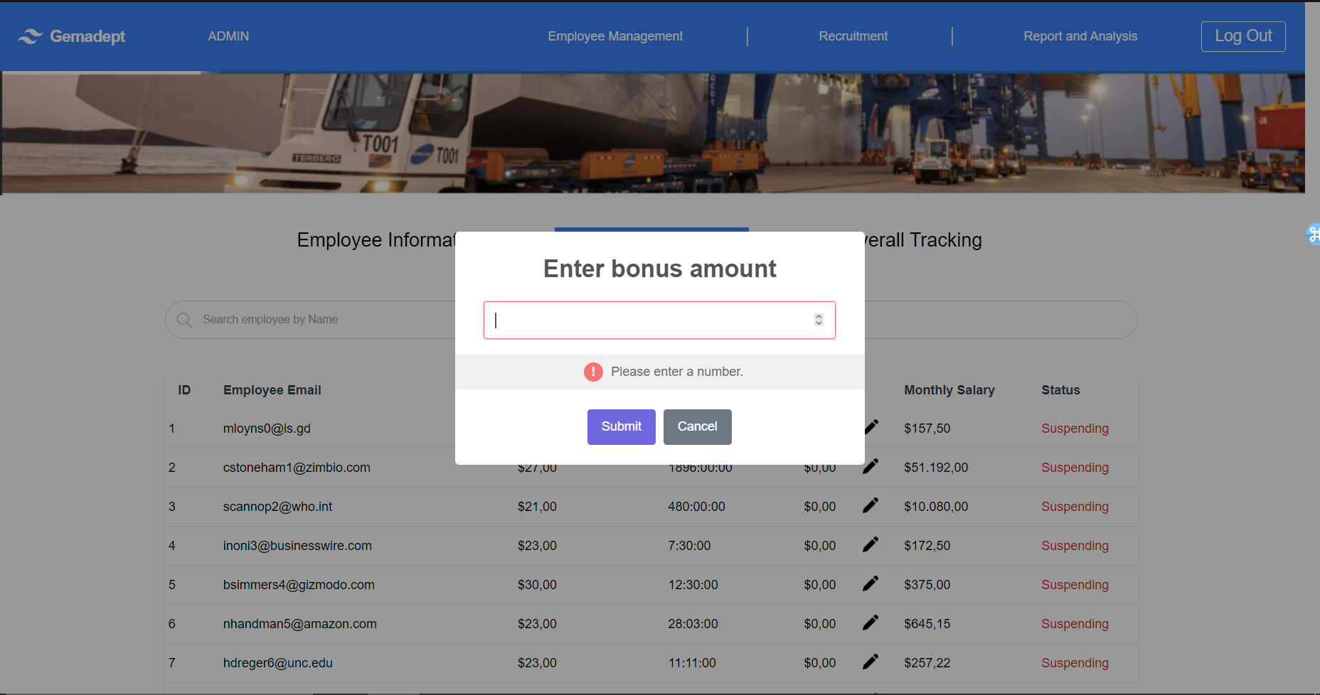

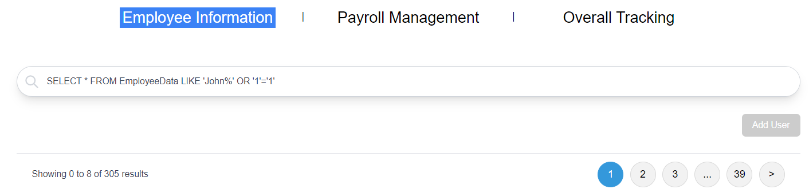

*Figure 2.44 – 2.51: Input Testing*

After testing, we can see that our input has passed a good number of test cases, and those with severe priority are addresses. Hence, this quality passes our benchmark.

**Group 3: Other Tests**

**Quality 14**: Error messages should be displayed when invalid data is entered, providing clear instructions on how to correct them.

**Testing measure**: Wrongly execute any input and observe whether error messages appear.

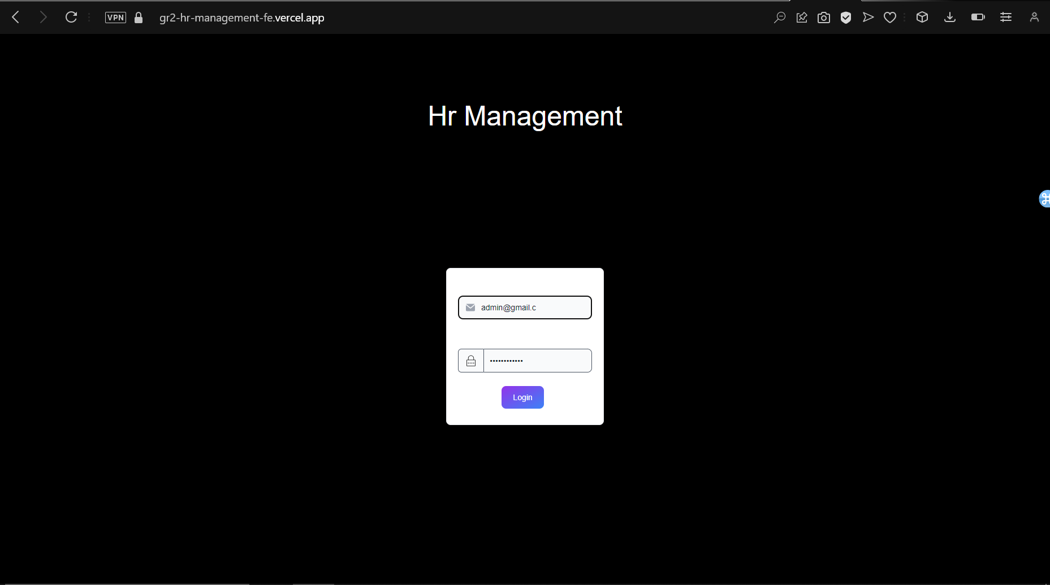

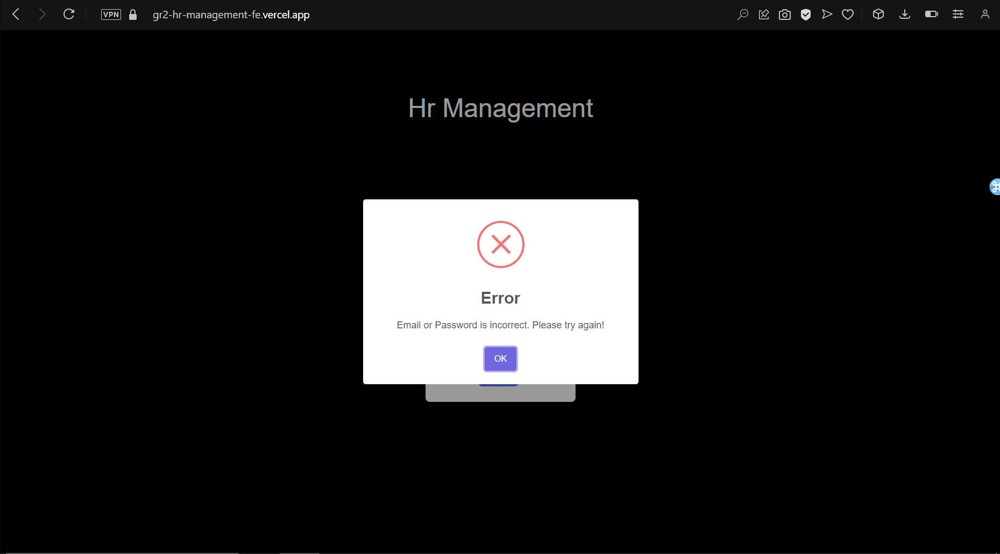





*Figure 2.52 – 2.55: Instruction Testing*

The invalid text prompt is correctly showing on our website. Hence this quality passed out benchmark.

**Quality 16**: API connection to other services (i.e., existing ERP, Google sign in, etc.) should have little error.

**Testing measure**: Intentionally disrupt network connectivity during an ongoing API request and verify that the system handles the timeout or connection failure gracefully.

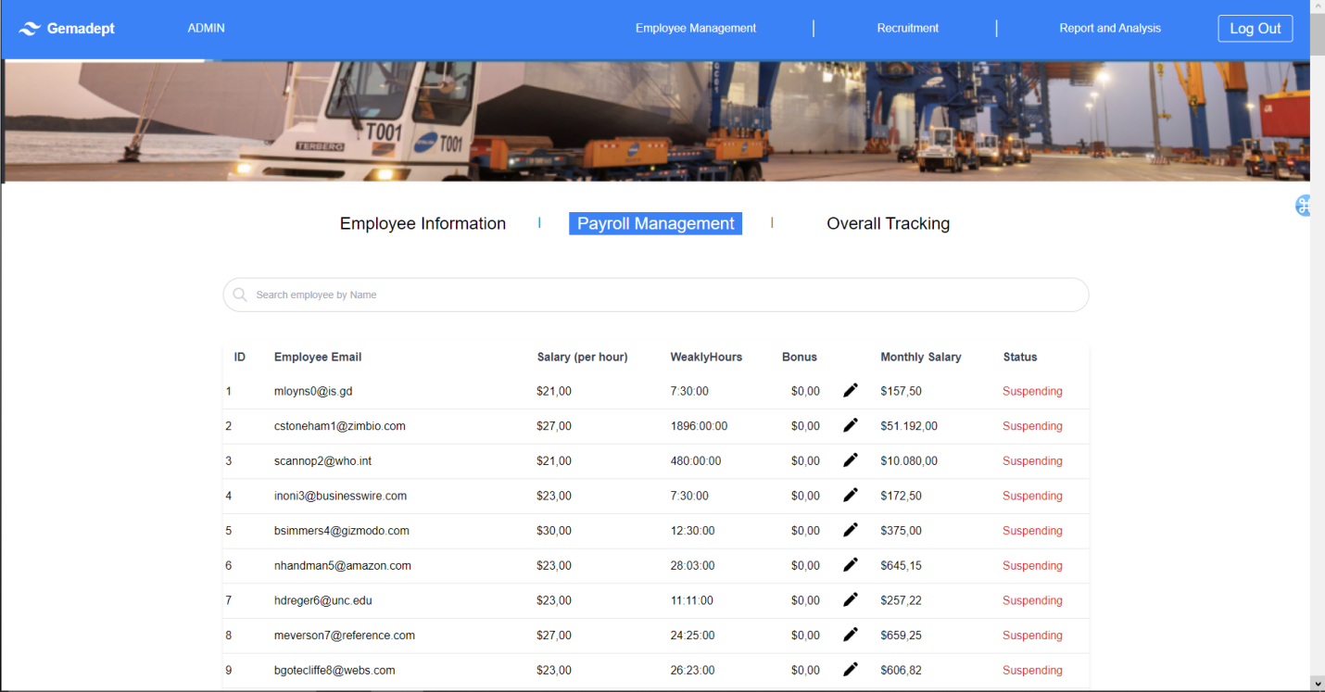

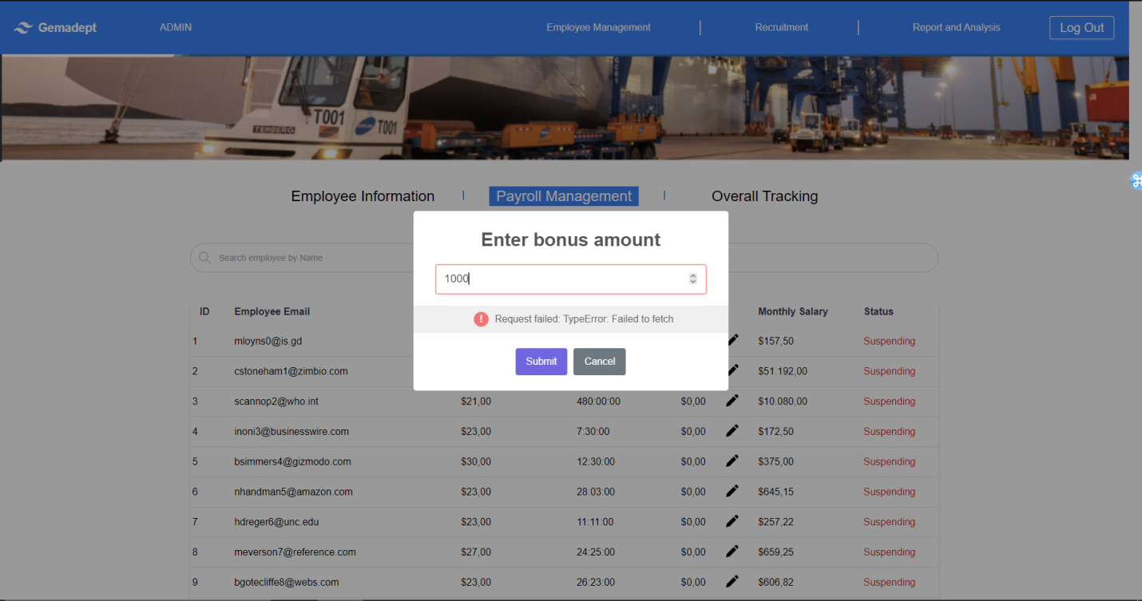

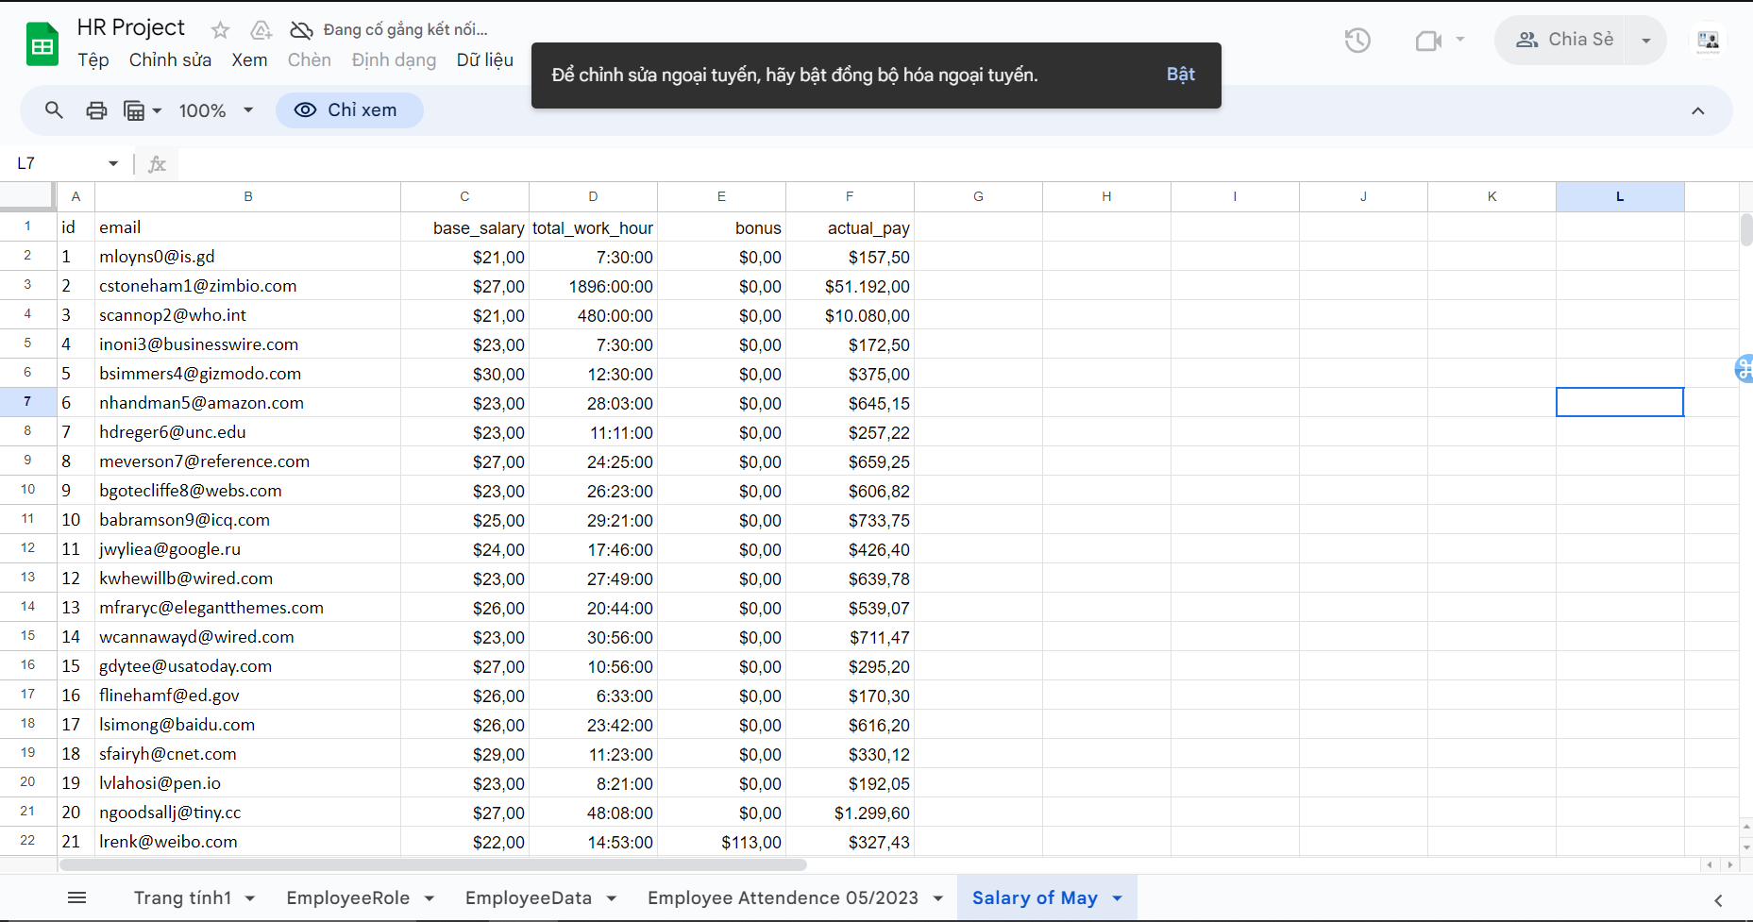

*Figure 2.56 – 58: API connectivity check*

We tested the API connectivity by disconnecting the device from the internet and attempted to add information on the website. As can be seen, the API failed to fetch, and data was not added to the database. This quality hence passed our benchmark.

**Report**

So, we were able to conduct quality testing for 6 out of 17 of our quality tests that were defined in the previous document. This means that we have yet to achieve the substantial amount of quality that was defined, and our product is lacking a significant amount. Moreover, some important and urgent quality has not been done.

The reason that we have not completed all the quality defined is due to the fact that our sprint was originally planned to be as long as 21 days, but we have only done 10 days of work as of this period of time. Hence, we can state that our backlog item (HRM website) does not satisfy the quality requirements defined.

1. **Rationale and Analysis**

**What Worked**:

* **Clear Task Definition**: The sprint backlog items, in my opinion, had well-defined goals and acceptance criteria. This helps teamwork become better while also making tasks in the sprint easier to follow through.
* **Achievable Thresholds**: We created achievable thresholds for our sprint goals and adhered to the SMART framework, so we had reasonable goals to strive for. Which adds to our ability to achieve a lot of quality in a limited amount of time.
* **Efficient Communication**: We had multiple channels of communication, which became very useful for exchanging ideas, solutions and urge one another to do tasks.

**What Did Not Work**:

* **Rushed Development**: As we had to do our sprint in a timeframe lower than what was planned, development activities were rushed, which leads to some compromission in code quality and could potentially introduce defects.
* **Inefficient Time Allocation**: With a limited timeframe, time was not always allocated efficiently, which results in delays or unfinished tasks towards the end of the sprint.
* **Too Many Qualities**: We tried to achieve too many quality metrics at the same time and may have stretched the team’s focus too thin.

**Future Recommendations**:

* **Improved Time Management**: We believe that we should put time tracking and task prioritizing strategies into practice. Which will hopefully help avoid last-minute rushes, and divide work into smaller, more manageable chunks and allot time wisely.
* **Quality Over Quantity**: We need to focus on tasks that have a higher priority first (e.g., urgent, and important task). We believe that would help us to concentrate efforts on key quality aspects, and the team can deliver more impactful results within the sprint timeframe, while putting the less important task for later.
* **Continuous Improvement**: As a team, we should strive for greater growth by valuing input, introspection, and using lessons from the past. To assess sprint performance, pinpoint areas for improvement, and execute iterative modifications to improve procedures and practices, more meetings are held.